***PART-1 [next time first comp skips]***

***[after finished open every and solve all todo question it will make revision and increase understanding]***

***Introduction***

* JavaScript’s capabilities greatly depend on the environment it’s running in. For instance, [Node.js](https://wikipedia.org/wiki/Node.js) supports functions that allow JavaScript to read/write arbitrary files, perform network requests, etc.
* In-browser JavaScript can do everything related to webpage manipulation, interaction with the user, and the webserver.
* Use shift+enter for multi line input in developer console

***JavaScript Fundamentals***

* JavaScript programs can be inserted almost anywhere into an HTML document using the <script> tag.
* Attachment of JS
* <script> tag internal
* <script src="/path/to/script.js"></script> external
* "use strict" code runs in a modern way, otherwise old way
* Ex of “use strict” num = 5; works in non strict mode but gives error in strict mode ; in strict mode we need to declare let num = 5
* <https://javascript.info/types>
* To convert something in Number and check weather it is a number or not , the correct way is 
* Conversions -- <https://javascript.info/type-conversions> [Skip]
* 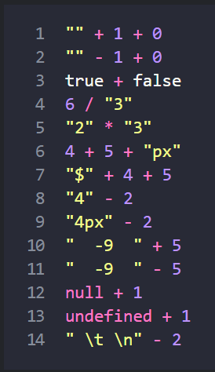 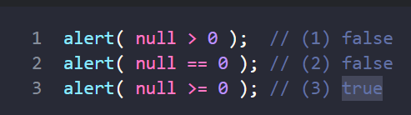 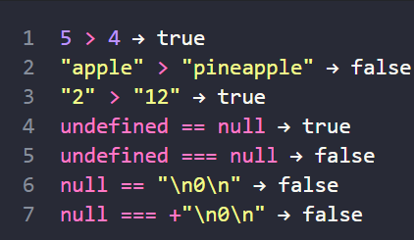
* 
* Comparisins check for null and undefined : <https://javascript.info/comparison>
* A number 0, an empty string "", null, undefined, and NaN all become false. Because of that they are called “falsy” values.
* Conditional operator ‘?’
* Do questions present here - <https://javascript.info/logical-operators> [Skip]
* ?? returns the first argument if it’s not null/undefined. Otherwise, the second one.
  + || returns the first truthy value.
  + ?? returns the first defined value.
* In JavaScript, a function is not a “magical language structure”, but a special kind of value.
* Revisit - <https://javascript.info/javascript-specials> [Skip]

***Code quality***

* Go through again- <https://javascript.info/comments> [Skip]
* Polyfills and transpilers
  + A transpiler is a special piece of software that translates source code to another source code. It can parse (“read and understand”) modern code and rewrite it using older syntax constructs, so that it’ll also work in outdated engines. (Babel, Webpack are some transpiler)
  + Polyfills -- New language features may include not only syntax constructs and operators, but also built-in functions.
  + A script that updates/adds new functions is called “polyfill”. It “fills in” the gap and adds missing implementations.

***Objects : the basics***

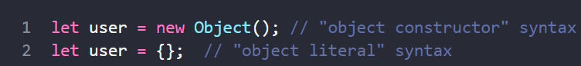

* The value can be of any type. Let’s add a boolean one: user.isAdmin = true;
* 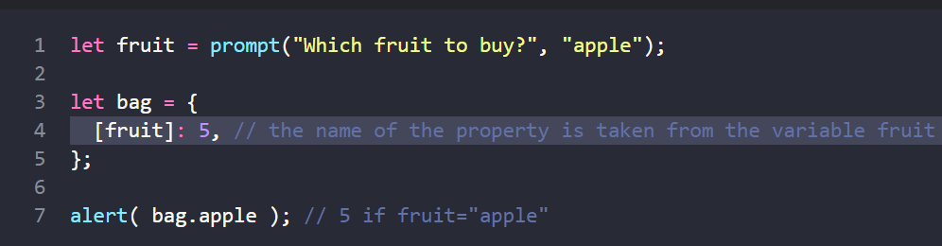
* Instead of name:name we can just write name, like this:
* 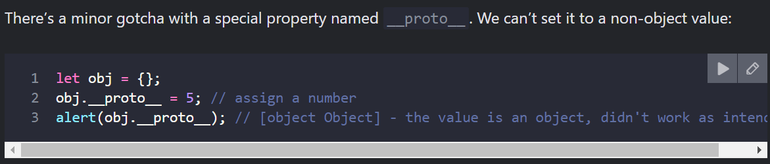
* In Objects , Reading a non-existing property just returns undefined. So we can easily test whether the property exists:
* We mostly use null for “unknown” or “empty” values. So the in operator is an exotic guest in the code.
* 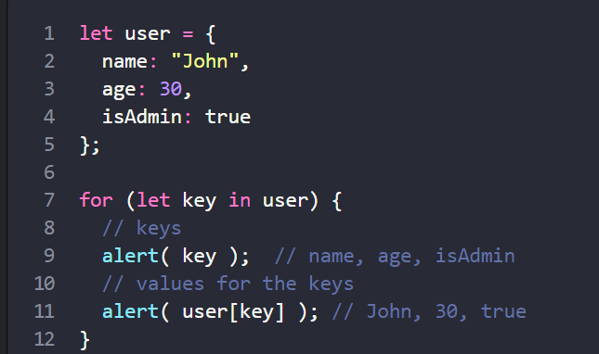 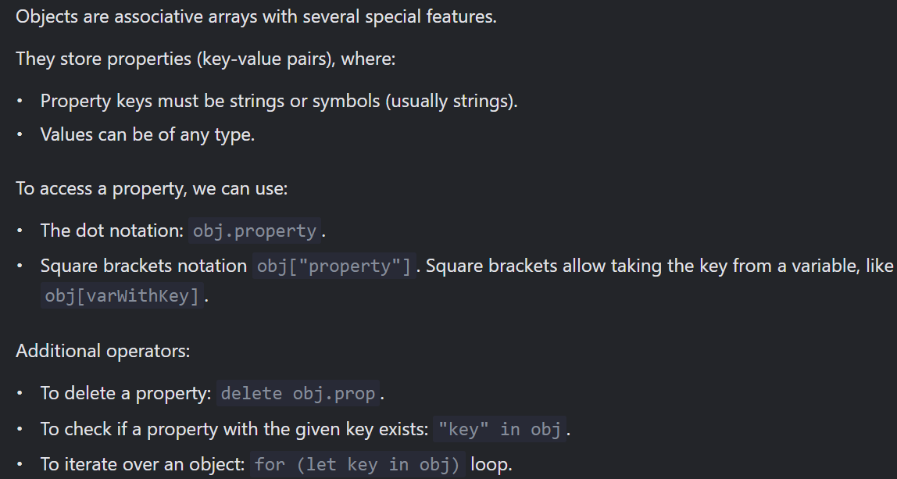
* Object.assign(dest ,…source) dest -target object , source – source Obj || return dest obj
* One more and easiest way is to use spread operator clone = {…user}
* Can also use const clone = structuredClone(user)
* Revisit nd get understanding about object and reference - <https://javascript.info/object-copy> [Skip]
* A function that is a property of an object is called its method.
* 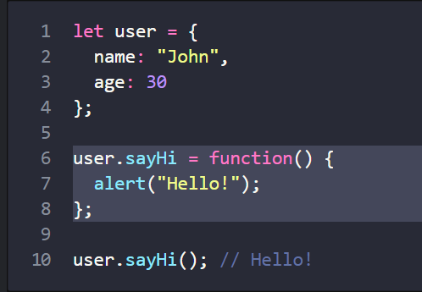 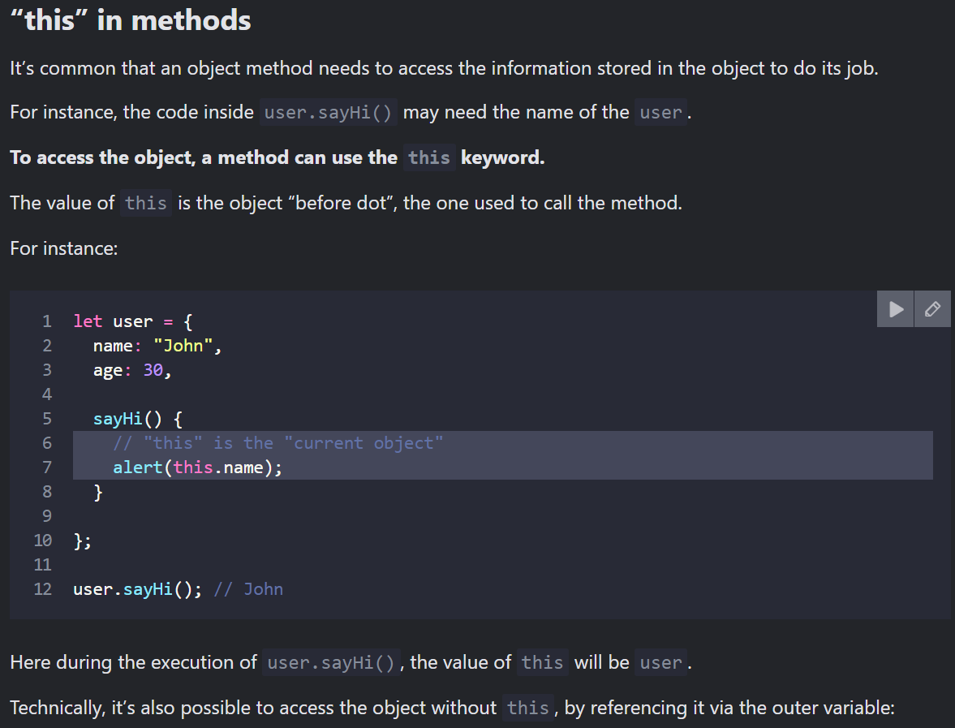 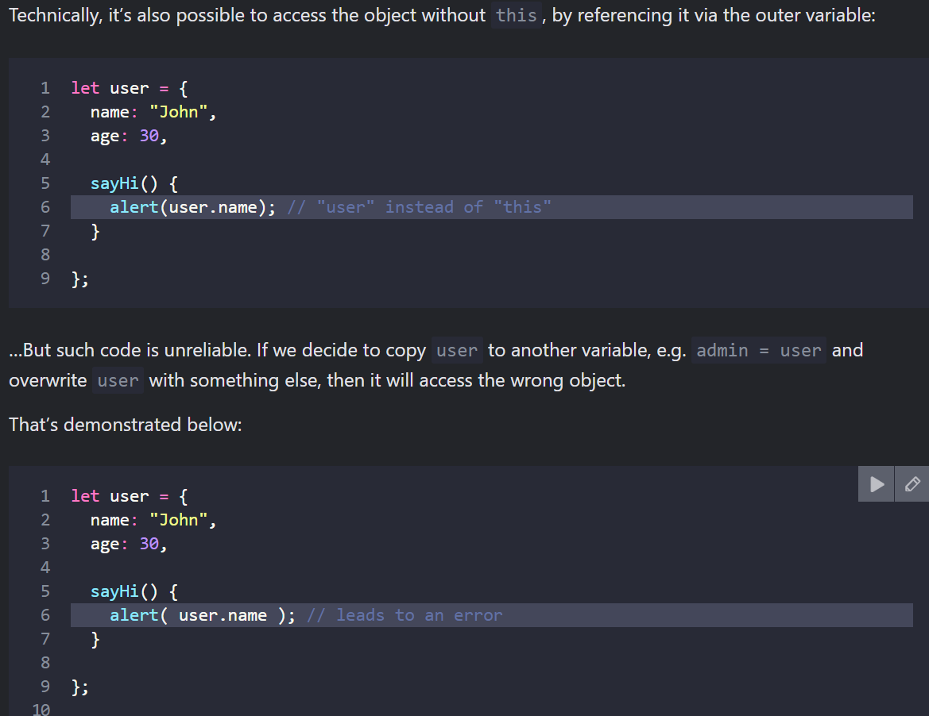 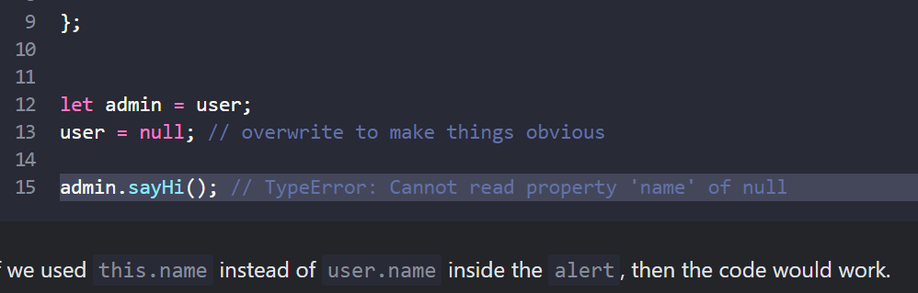
* 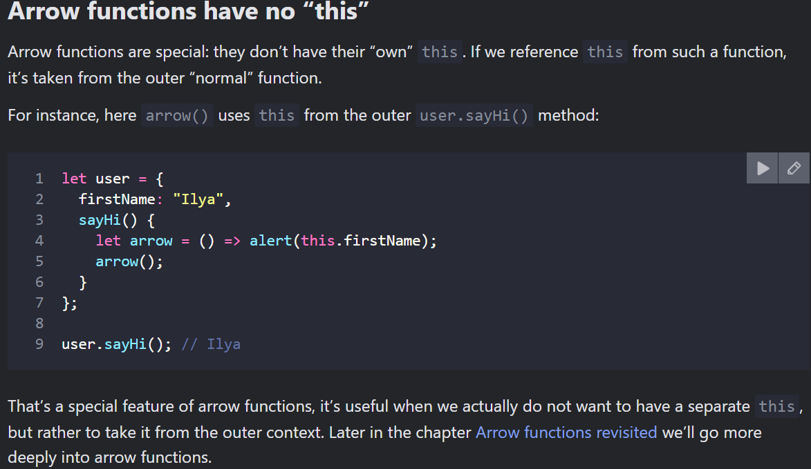
* Do Questions of this for Better THIS understanding - <https://javascript.info/object-methods> [Skip]
* If want to create multiple objects with same kind of content , we can create a JS function and its instance it is known as constructor function.
* 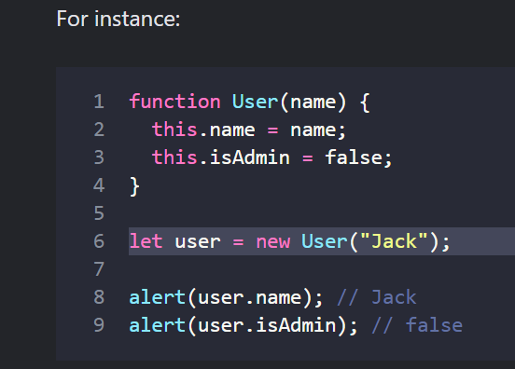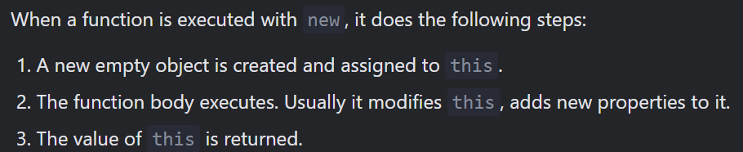
* That’s the main purpose of constructors – to implement reusable object creation code.
* technically, any function (except arrow functions, as they don’t have this) can be used as a constructor. It can be run with new, and it will execute the algorithm above.
* Their task is to write all necessary stuff into this, and it automatically becomes the result.
* The above is one type of object we can create , Other we can use classes
* Optional chaining '?.' -- This is a recent addition to the language. Old browsers may need polyfills.
* The optional chaining ?. is a safe way to access nested object properties, even if an intermediate property doesn’t exist.
* let html = document.querySelector('.elem')?.innerHTML; // will be undefined, if there's no element || We get undefined if value does not exist but we will not get error.
* Symbols -- A “symbol” represents a unique identifier. A value of this type can be created using Symbol():
* 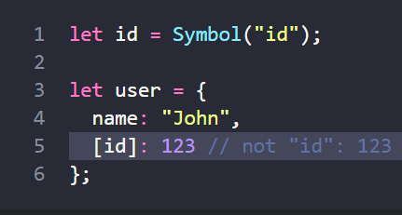
* Object Conversison -- <https://javascript.info/object-toprimitive> [Skip]

***Data types – Go through this again if possible***

* The “object wrappers” are different for each primitive type and are called: String, Number, Boolean, Symbol and BigInt. Thus, they provide different sets of methods.
* Primitive Methods read again with questions - <https://javascript.info/primitives-methods> [Skip]
* 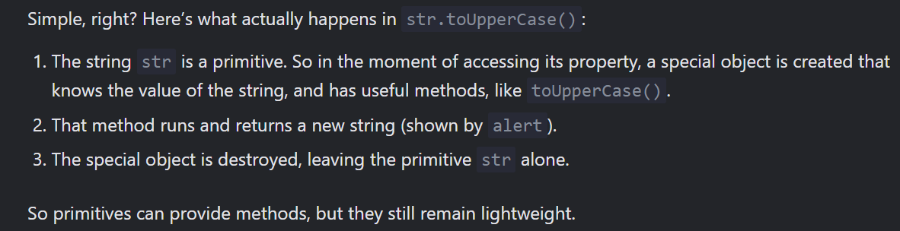
* 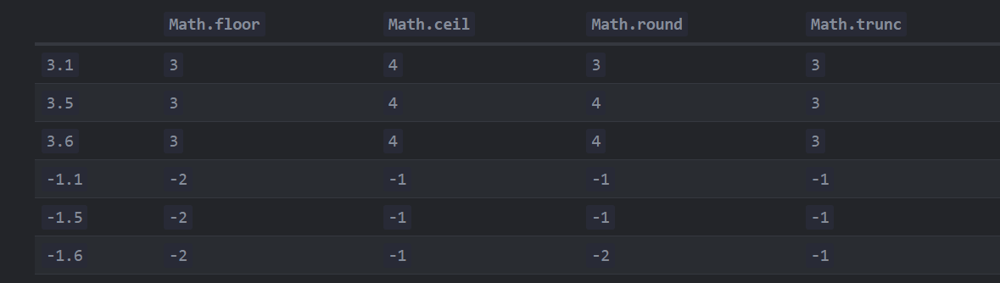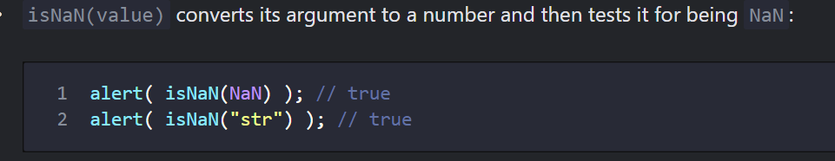
* <https://javascript.info/number#tests-isfinite-and-isnan> [Skip]
* Imp to understand all and do ques also Read Entire better understanding of No <https://javascript.info/number> [Skip]
* 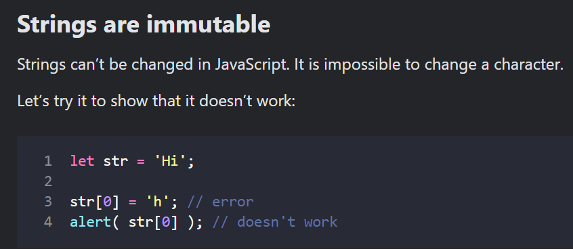
* Methods toLowerCase() and toUpperCase() change the case: ,, The first method is str.indexOf(substr, pos). ,, includes, startsWith, endsWith
* For finding substring 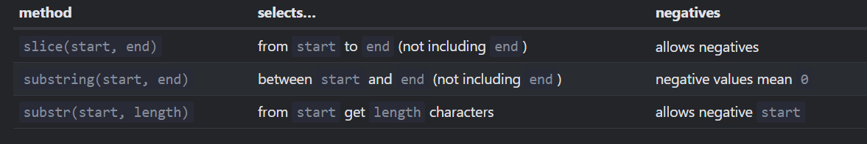
* 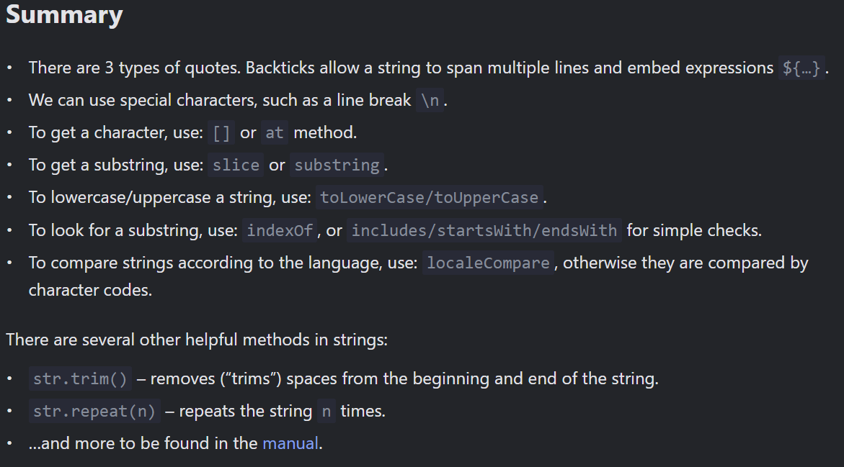
* Arrays –
  + Get last elements with “at” -- This is a recent addition to the language. Old browsers may need polyfills.
  + <https://javascript.info/array> go though again [Skip]
  + Stack -- LIFO (Last-In-First-Out) – Push Pop
  + Queue – FIFO (First-In-First-Out) – push shift
  + In computer science, the data structure that allows this, is called deque.
  + Array is an object and thus behaves like an object. Array has similar property like an object
  + Array and Objects are copy by reference (two variables reference the same array)
  + <https://javascript.info/array> with question go through again [Skip]
  + arr.splice(0, 2) – can do everything add, remove elements give new array as well.
  + Arr.slice(start, end) --- gives new array in return
  + 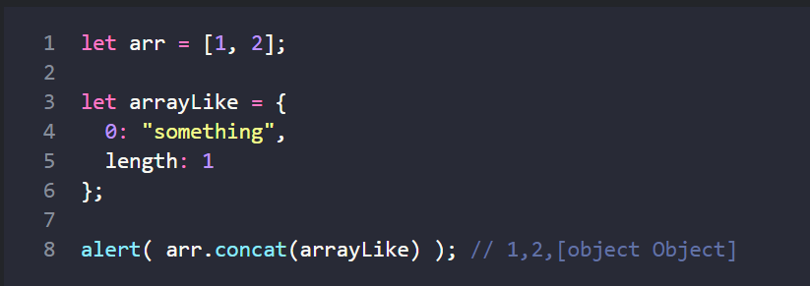
  + arr.includes **The includes method handles NaN correctly**
  + sort(fn)
  + 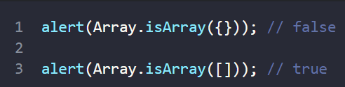 To check if this is array or not
  + Do Question of this - <https://javascript.info/array-methods> [Skip]
  + **filter --** filter returns an array of all matching element
  + 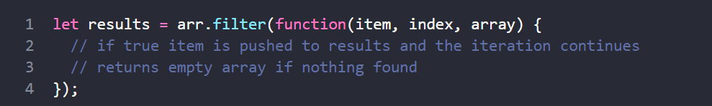
* Map and Set –
  + [Map](https://developer.mozilla.org/en-US/docs/Web/JavaScript/Reference/Global_Objects/Map) is a collection of keyed data items, just like an Object. But the main difference is that Map allows keys of any type.
  + 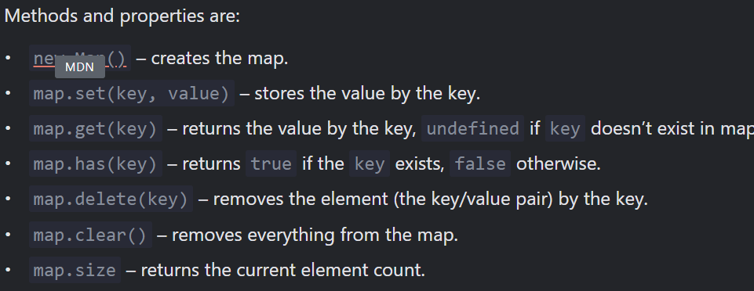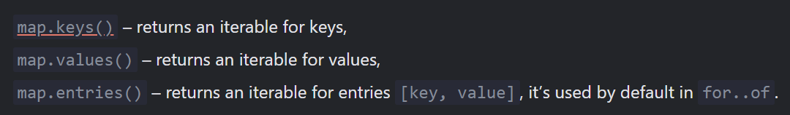
  + let map = new Map(Object.entries(obj)); get map from object
  + 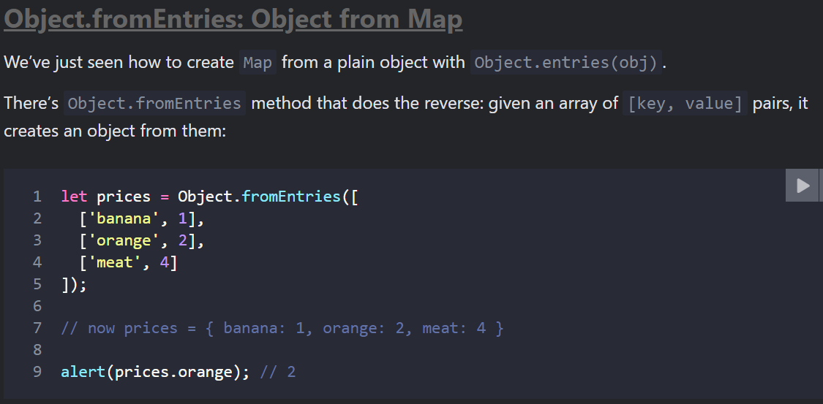
  + 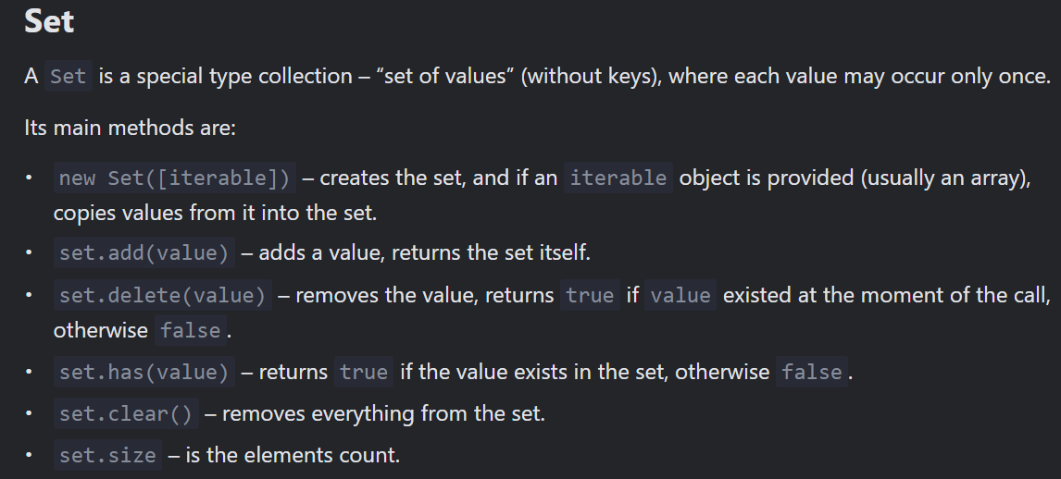
  + Set keeps only unique values , We can loop over a set either with for..of or using forEach:
  + 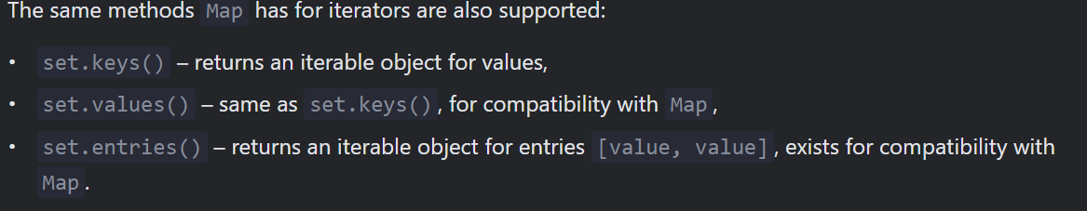
  + Do - Questions <https://javascript.info/map-set>
* Object.keys, values, entries
  + 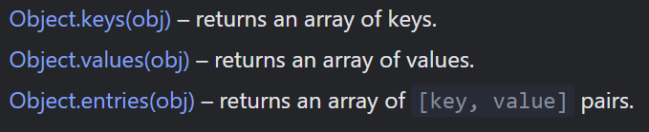
* Destructuring Assignment – Good visit again <https://javascript.info/destructuring-assignment>
  + *Destructuring assignment* is a special syntax that allows us to “unpack” arrays or objects into a bunch of variables, as sometimes that’s more convenient.
  + Array destructuring - 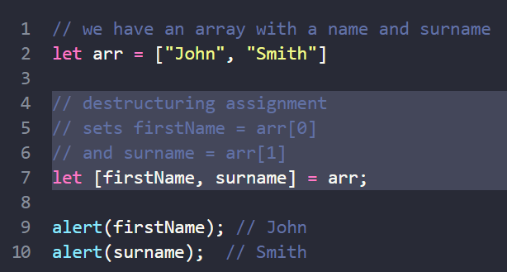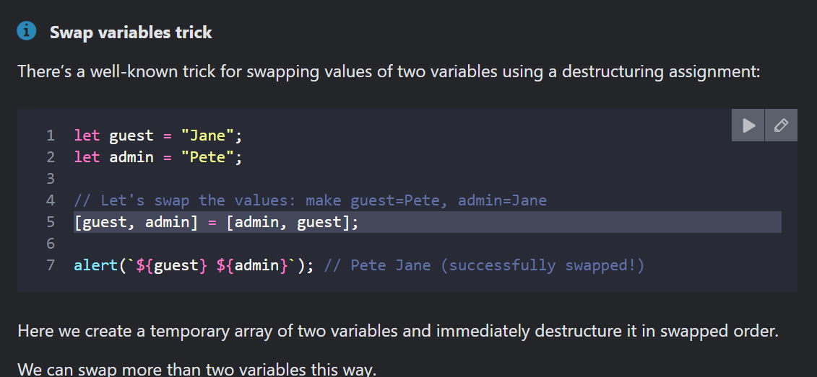
  + Object Destructing - let {var1, var2} = {var1:…, var2:…}
  + The rest pattern “…”
  + <https://javascript.info/date> date ques do
* JSON methods, toJSON
  + Let’s say we have a complex object, and we’d like to convert it into a string, to send it over a network, or just to output it for logging purposes.
  + JSON.stringify to convert objects into JSON.
  + JSON.parse to convert JSON back into an object.
  + 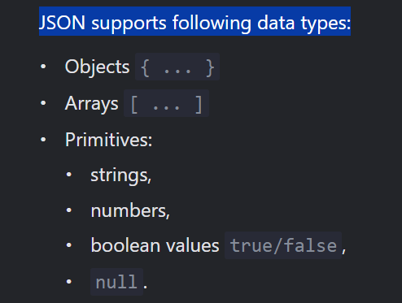

***Advanced Working with functions – not mandatory but can go thrugh this again***

* Skip - <https://javascript.info/recursion> not needed now .
* Rest parameters and spread syntax
  + The ...rest must always be last. 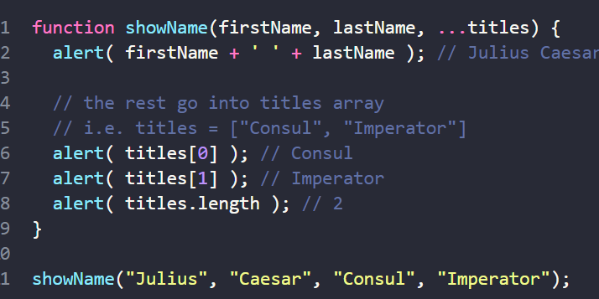
  + Spread syntax -- 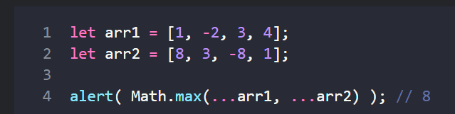 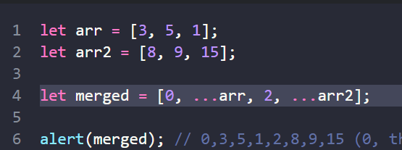
  + The spread syntax works only with iterables.
  + 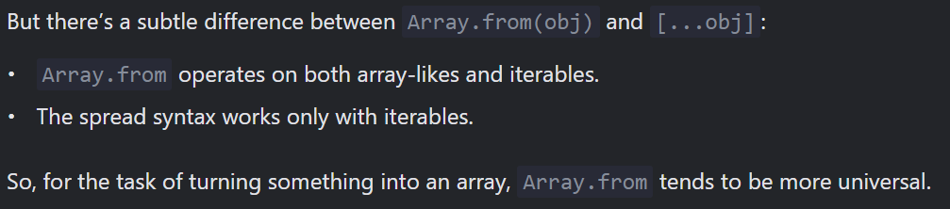
* ***Variable scope, closure***
  + 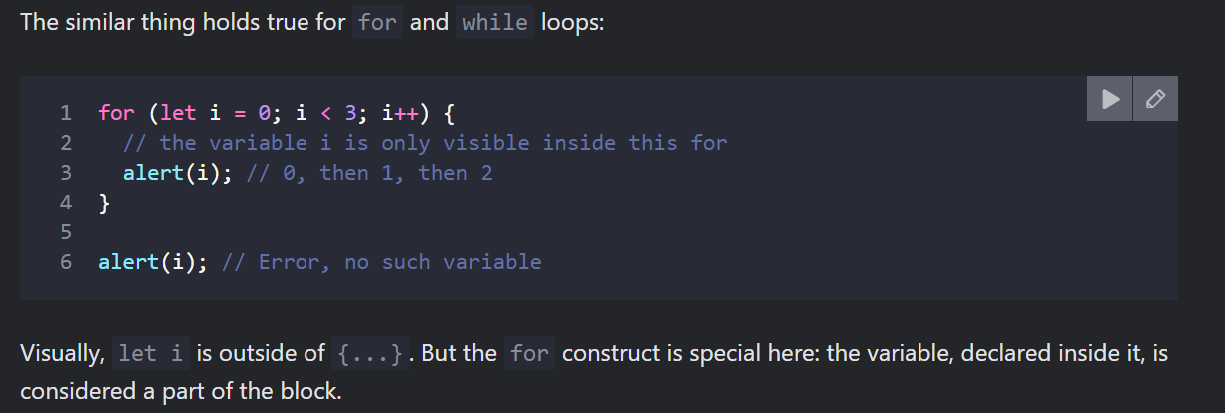
* ***Lexical Environment -*** 
  + [***https://javascript.info/closure***](https://javascript.info/closure)visit this again and solve questions also
* Variables, declared with var, are either function-scoped or global-scoped. They are visible through blocks.
* “var” variables can be declared below their use <https://javascript.info/var> got though again
* 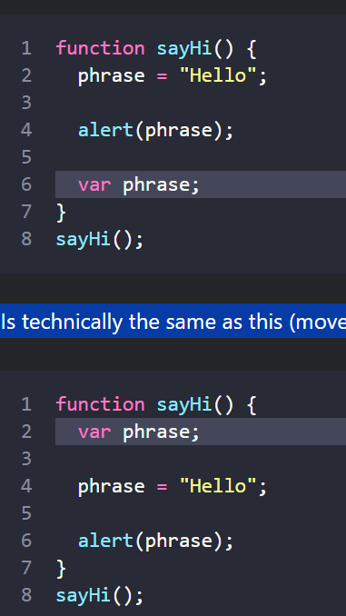
* People also call such behaviour “hoisting” (raising), because all var are “hoisted” (raised) to the top of the function.
* ***Scheduling: setTimeout and setInterval***
  + We may decide to execute a function not right now, but at a certain time later. That’s called “scheduling a call”.
  + 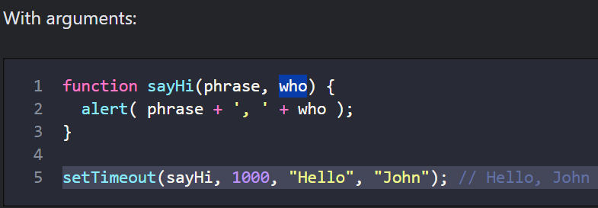 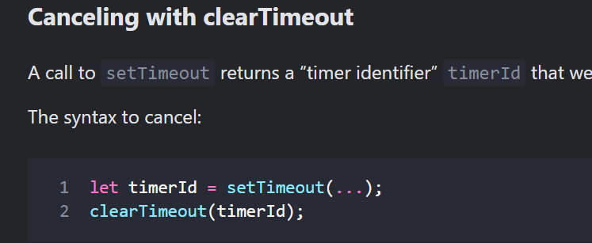
  + 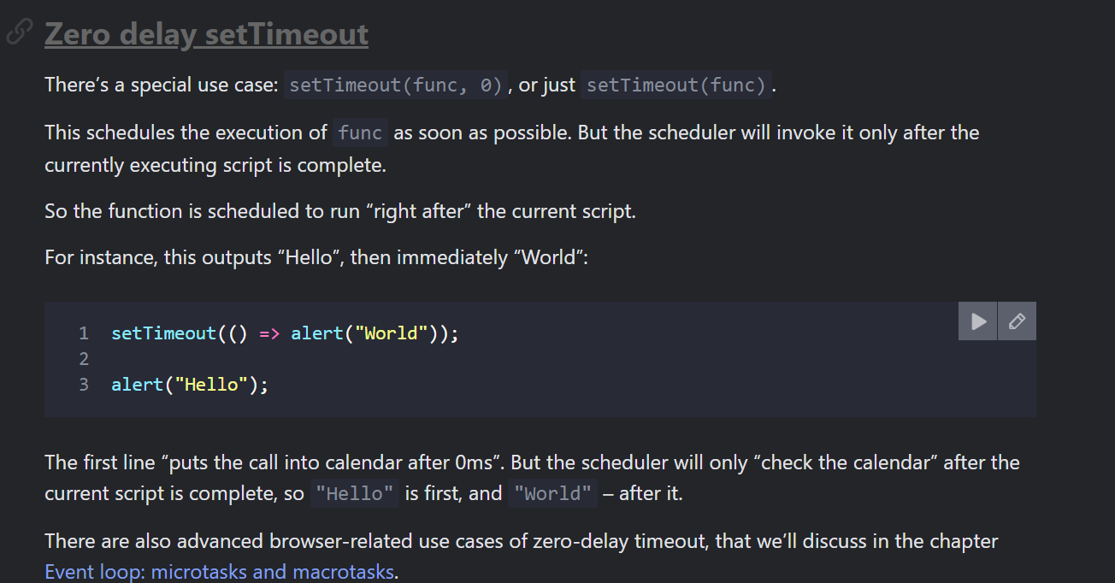
* ***Decorators and forwarding, call/apply -*** [***https://javascript.info/call-apply-decorators***](https://javascript.info/call-apply-decorators)go through again good debouncing and all are there
* ***Function Binding –*** 
  + `When passing object methods as callbacks, for instance to setTimeout, there’s a known problem: "losing this".
  + <https://javascript.info/bind> go through again better understanding of bind
* ***Arrow functions revisited*** 
  + Arrow functions can’t run with new -- Not having this naturally means another limitation: arrow functions can’t be used as constructors. They can’t be called with new.
  + Arrow functions: Do not have this, Do not have arguments, Can’t be called with new They also don’t have super

***Object properties configuration –***

* ***Property flags and descriptors*** 
  + 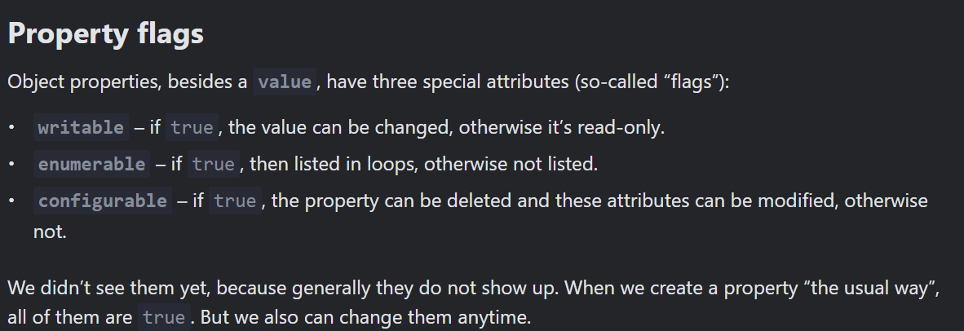
  + 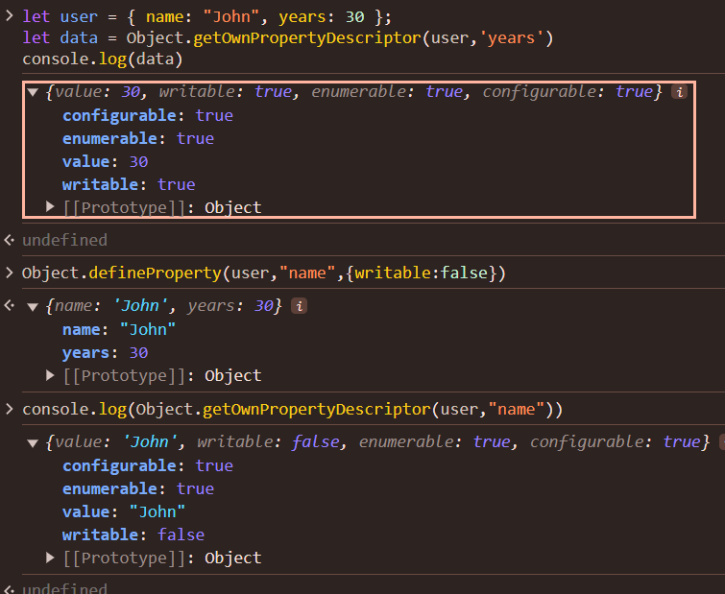 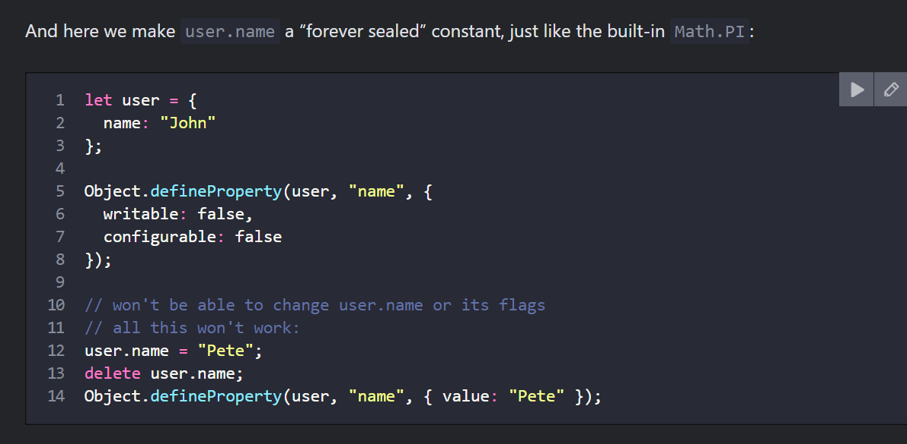
  + 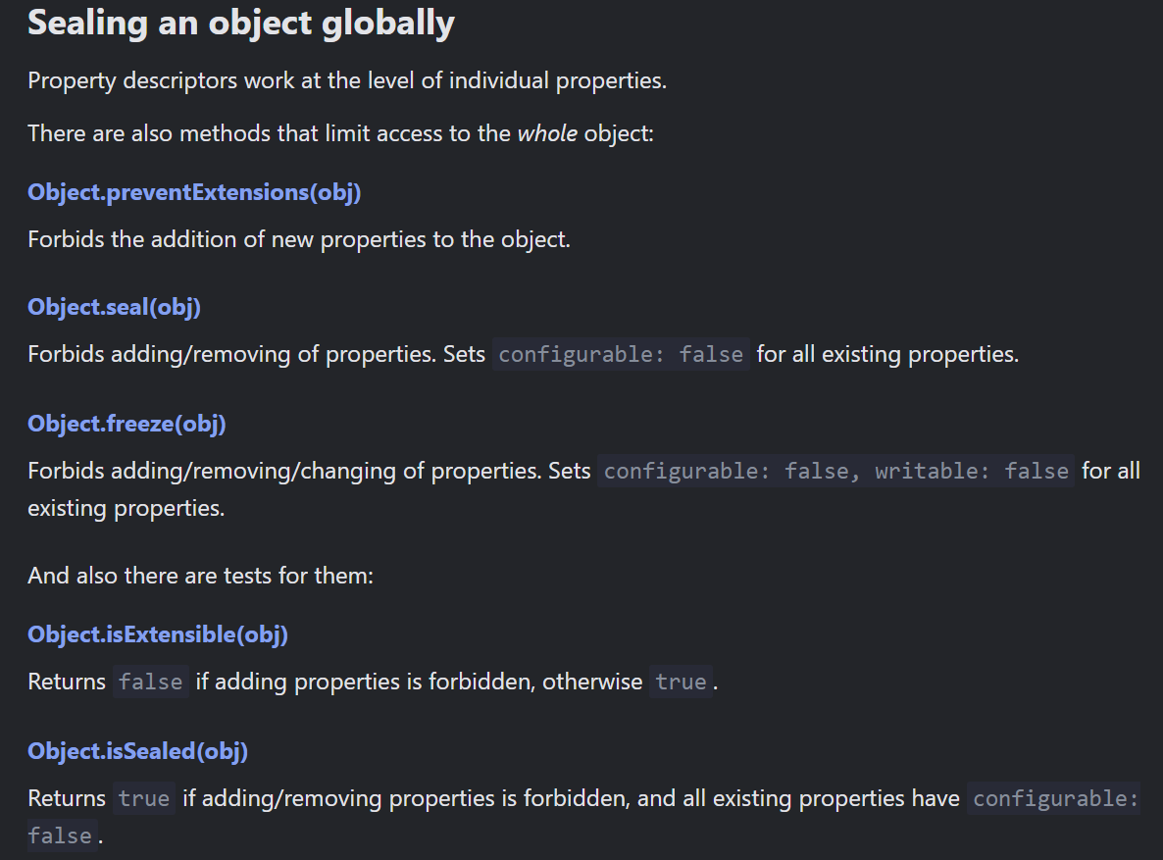 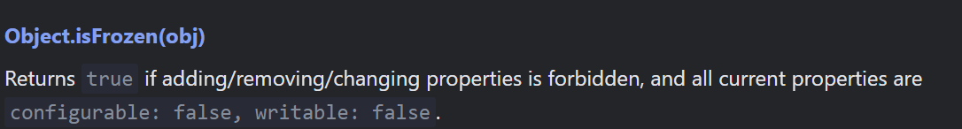
* ***Property getters and setters***
  + 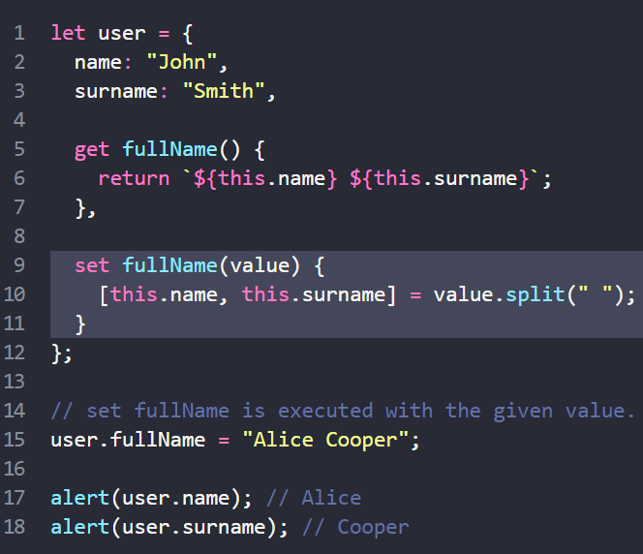

***Prototypes, inheritance– good for know and advance int. read again for this – but now not mandatory***

* <https://javascript.info/prototype-inheritance> -- read again good
* _proto_ can be used for prototype inhertance
* 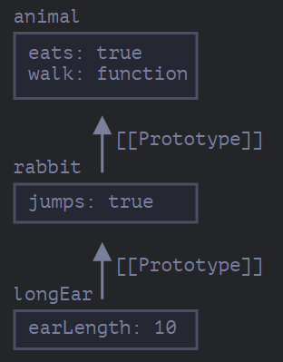
* <https://javascript.info/native-prototypes> important got to know what is [object Object]

***Classes – skip will do this when time permits [tough]***

* Classes basic syntax
  + But in the modern JavaScript, there’s a more advanced “class” construct, that introduces great new features which are useful for object-oriented programming.
  + In JavaScript, a class is a kind of function.
* Class inheritance
  + Class inheritance is a way for one class to extend another class.

***Error handling -***

* ***Error handling, "try...catch"***
  + 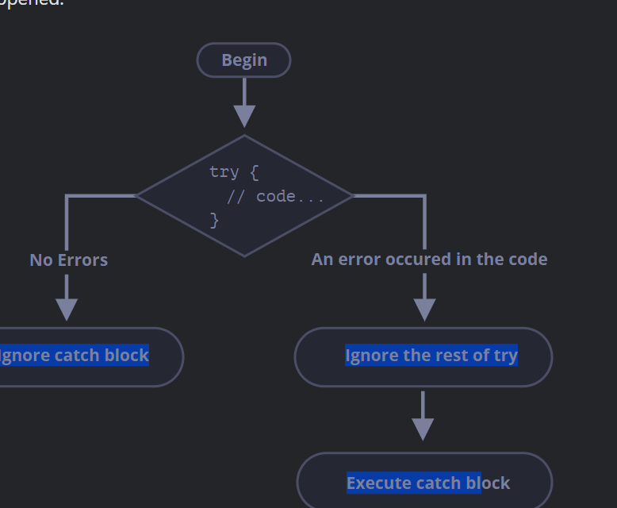 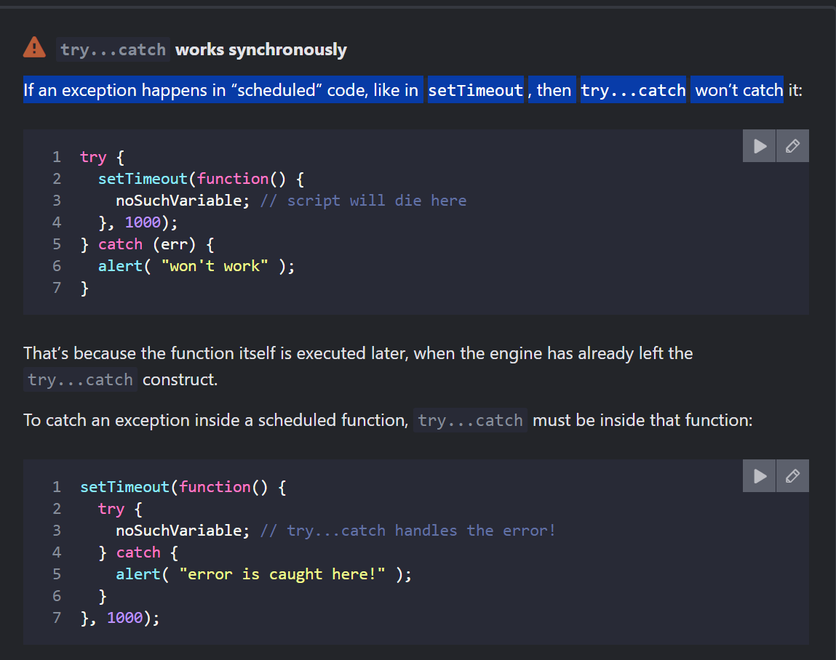
  + 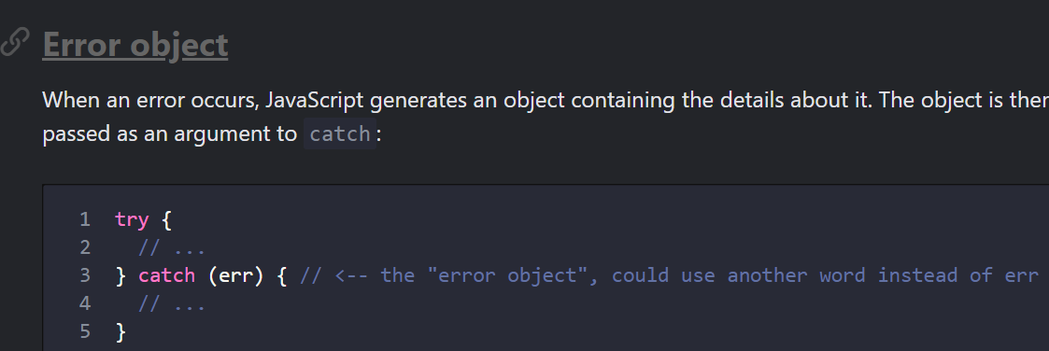 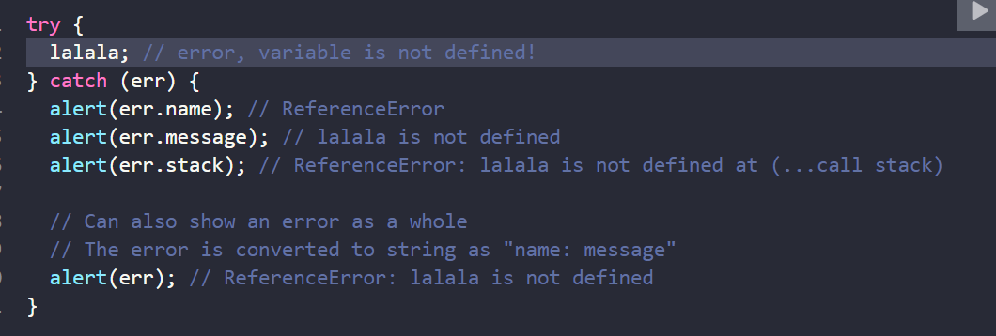
  + <https://javascript.info/try-catch#throw-operator> Read this throw operator part – Read from below this part.
  + <https://javascript.info/custom-errors> read again , check where error is throughed inside catch and how does it work.
* ***Custom errors, extending Error***
  + <https://javascript.info/custom-errors> good to understand errors see when working with error handling

***Promises, async/await -***

* ***Introduction: callbacks***
  + Bad way callback hell and pyramid of boom
* ***Promise***
  + 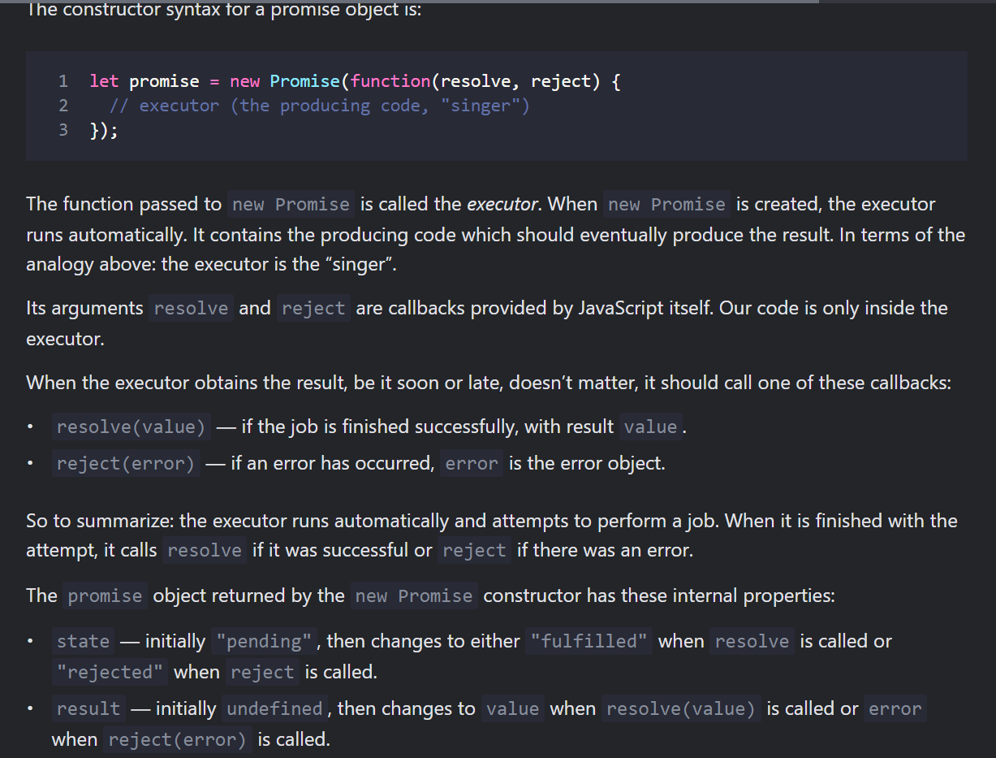 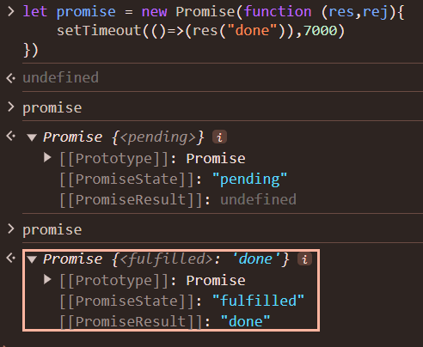
  + Bad way callback hell and pyramid of boom
* ***Promise Chaining***
  + The whole thing works, because every call to a .then returns a new promise, so that we can call the next .then on it.
* ***Error Handling with promises***
* Promise API
  + Promise.all , Promise.allSettled , Promise.race ,promise.any
* Async/Await
  + The word “async” before a function means one simple thing: a function always returns a promise. Other values are wrapped in a resolved promise automatically.
  + So, async ensures that the function returns a promise, and wraps non-promises in it. Simple enough, right? But not only that. There’s another keyword, await, that works only inside async functions, and it’s pretty cool.
  + The keyword await makes JavaScript wait until that promise settles and returns its result.

***Extras***

***Execution Context***

* JavaScript Execution Context is the environment in which JavaScript code is executed.
* Everything in JS happens inside execution context. It has 2 components -Memory Creation, Thread of Execution
* Thread of execution – Code executed one line at a time
* JS is synchronous singlethreaded language (one line at a time and only move to next line when one line finish its exeution)
* 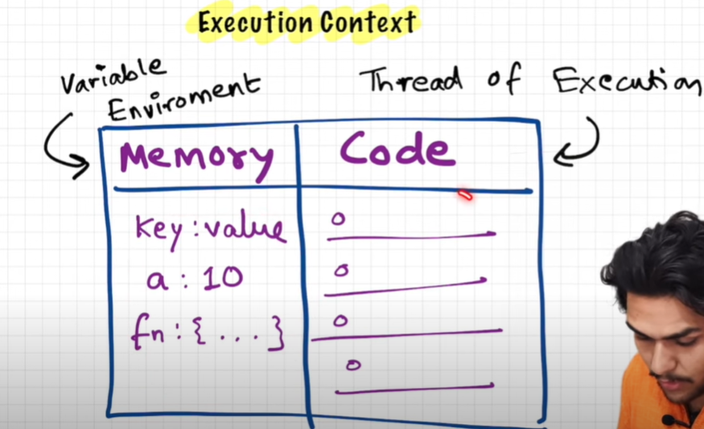
* Global Execution context is created in two phases – 1. Memory Creation phase, 2. Code Execution Phase
  + Phase 1- 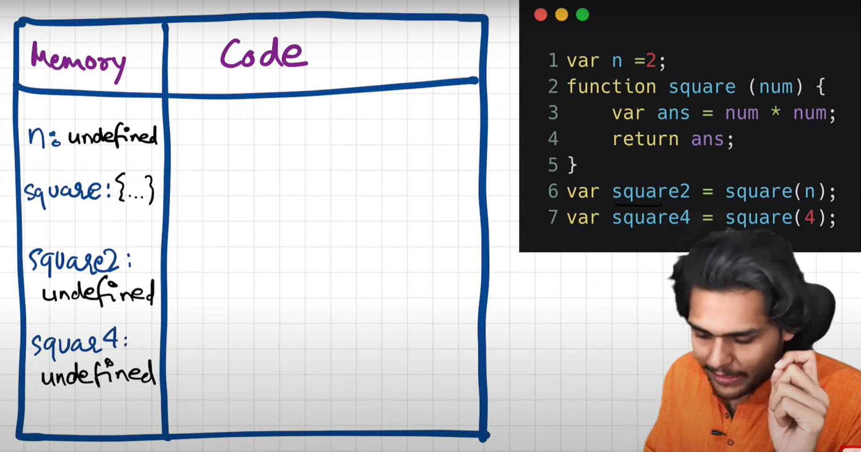
  + n set to undefined, and square set to function reference
  + Phase 2- Code Execution Phase | 2-5 there is nothing to execute | at line 6 we have function invocation | function is like a mini program for every function invocation a new execution context is created other than global execution context and it will be deleted just after it return the data to global execution context. 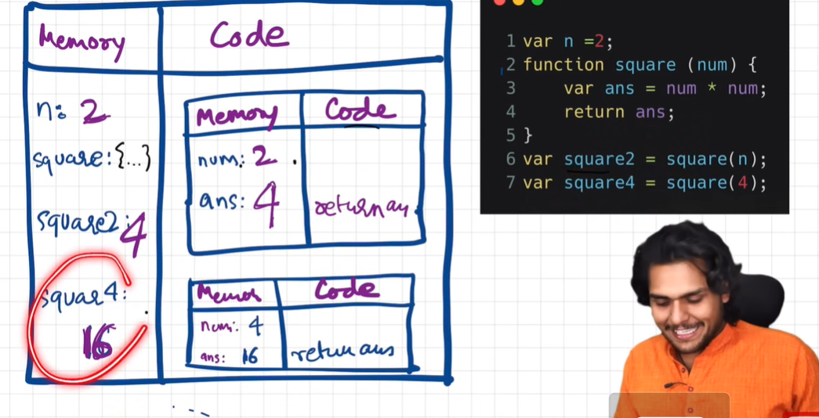 
  + After program gets finished entire execution context gets deleted and this entire thing is managed in call stack | call stack maintain order of execution context and it is also known as call stack , execution context stack , program stack ,control stack , runtime stck , machine stack.
  + 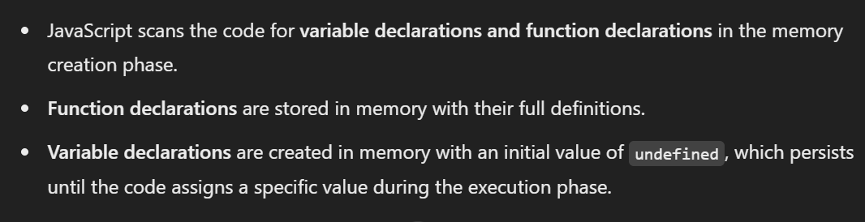
  + Cross ques – let and const , arrow and other function concept , show with ex, and real ex , console.log() functions and var above

***Hoisting in JS***

* **Hoisting** (moves (or "hoists") in JavaScript is a behaviour where variables and function declarations are moved to the top of their containing scope during the compile phase before the code actually runs. This means that you can use variables and functions before you declare them in your code.
* But when we define variable it gets undefined as it is declared by knowledge of execution conext but assigning of value happens afterwards.
* **Functions**: Hoisted entirely (you can call them before declaring).
* **var Variables**: Hoisted, but initialized to undefined (you can access them before declaring, but they’ll be undefined).
* **let and const Variables**: Hoisted but not initialized (accessing them before declaring throws an error).
* 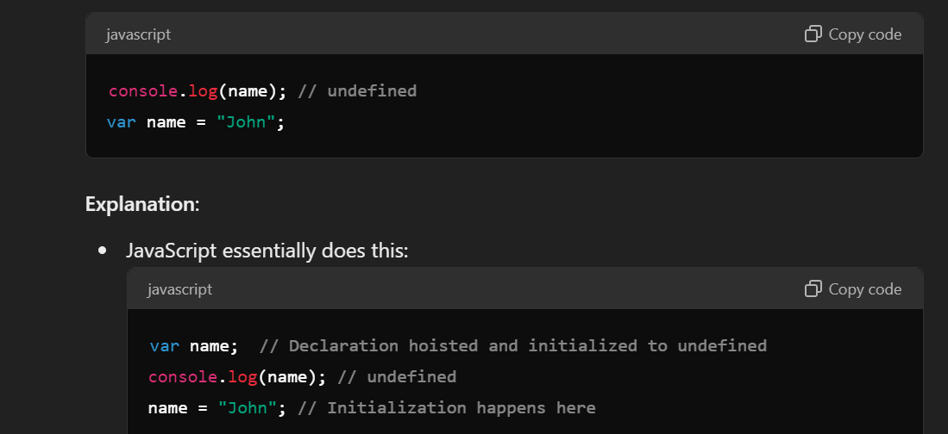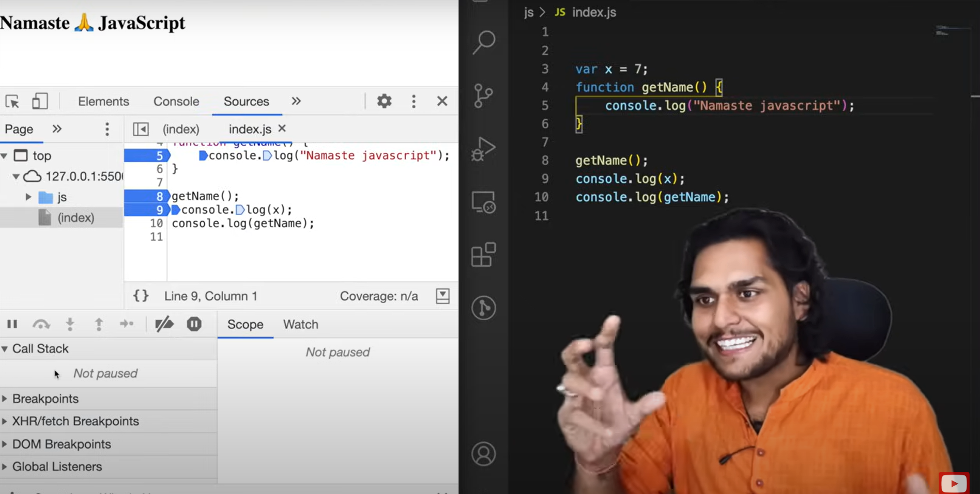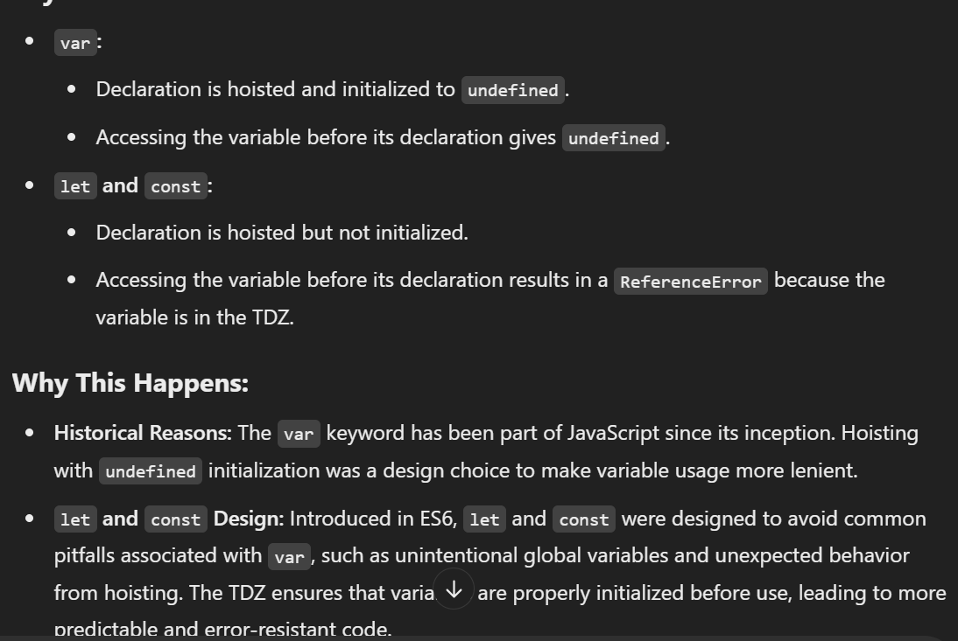
* 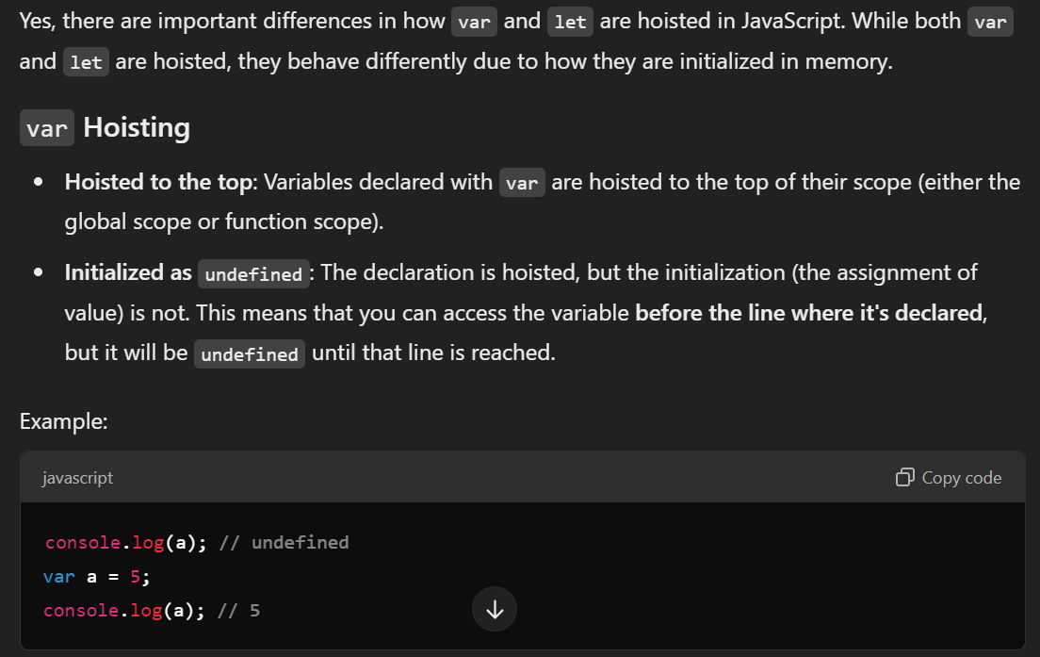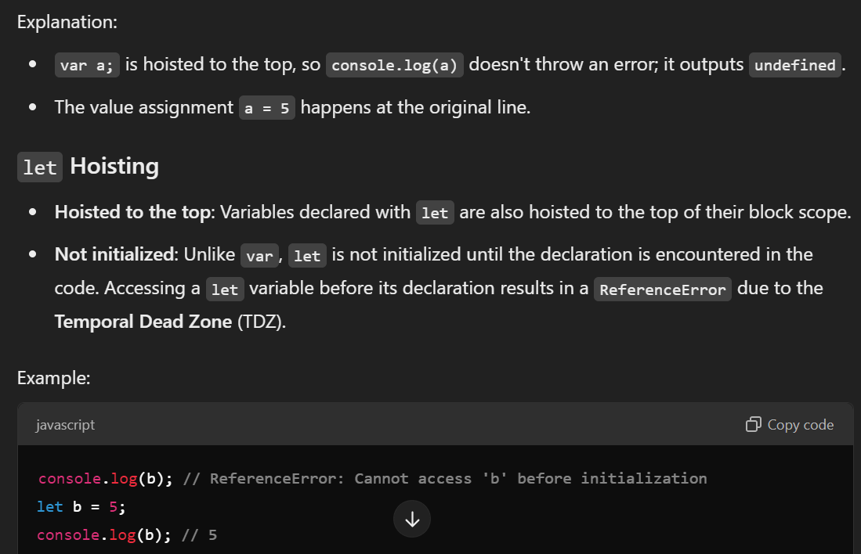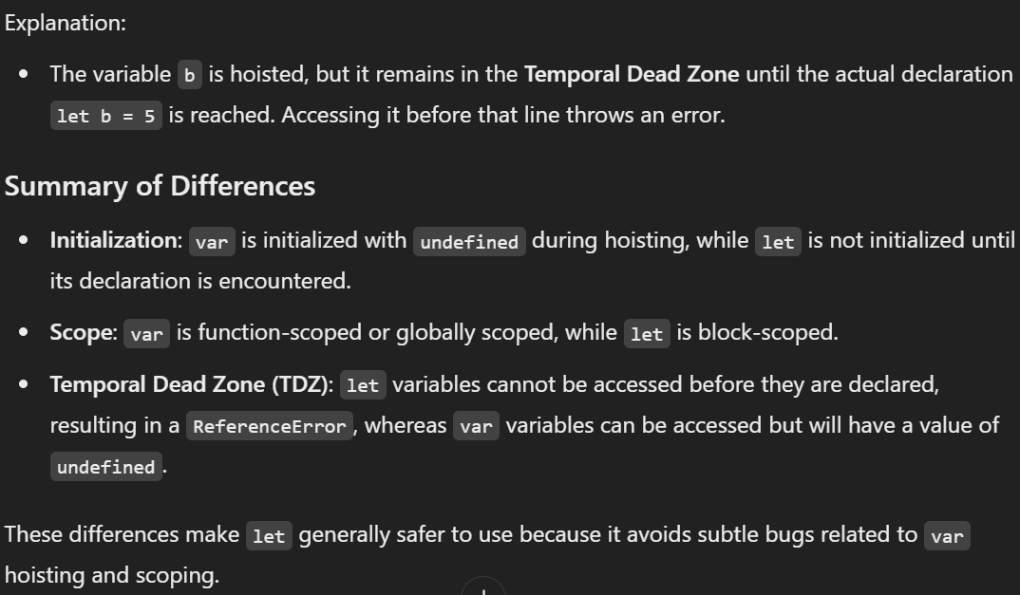

***Function Works in JS-***

* Same knowledge of execution context can be explained inside function
* 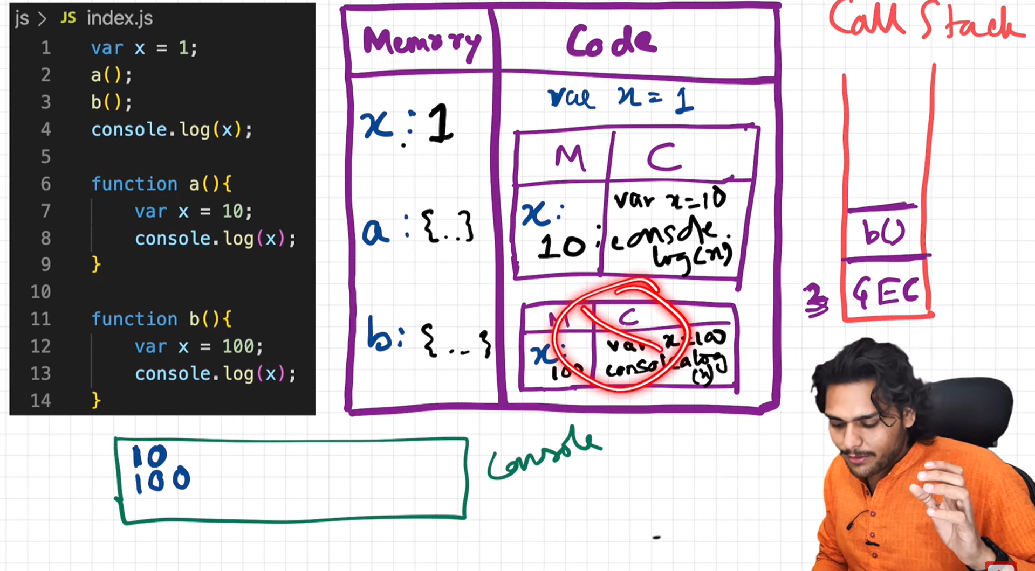
* After execution of entire code or separate function each execution context is deleted and later after execution entire program even global execution context is deleted and popped out. (remember global and local memory)
* Cross Ques – Show & Implement and check this in browser console also.

***undefined vs not defined in JS-***

* JS creates global execution context and allocates the memory to all variable and function before any code is executed and initialize it with undefined
* If we have allocated memory to a and its value is not initialized then it will be undefined , but if we have console x variable which is not declared then it will throw not defined , Not defined is something which is not allocated to memory
* JS is loosely types language(also knows as weakly typed lang) , means it does not have any specific datatype.

***The Scope Chain*** ***–***

* What is scope chain is like if we declare variable a , and function inside function we can access variable a this is because scope chain
* Along with execution context we get lexical environment of its parent (value of variable of parent) (lexical means in hireacchy)
* C is lexicallt inside a , a is lexically inside global scope
* 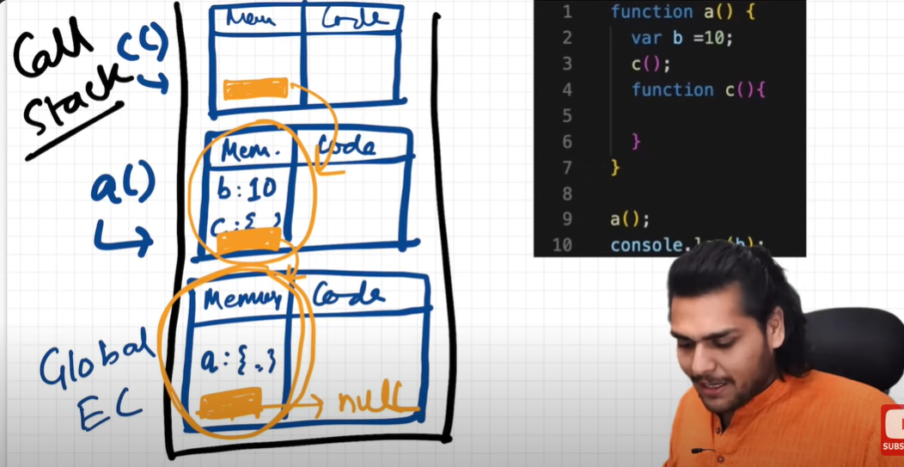 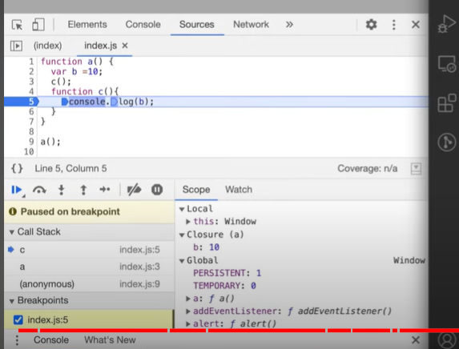
* Lexical environment is created whenever Execution context is created nd Lexical environment is Local Memory & Reference to lexical environment of parent.
* Lexical environment is the local memory (its memory space ) along with lexical environment of its parent.
* The chain of this lexical env is known as scope chain , and if variable is not present in scope chain we say scope chain is exasted
* An this one inside other is known as scope chain.
* Watch last 9 min video

***let const , tempDead Zone in JS*** ***–***

* Let and const declarations are hoisted but this are in temp dead zone for the time being
* Error is cannot access variable before initialization
* 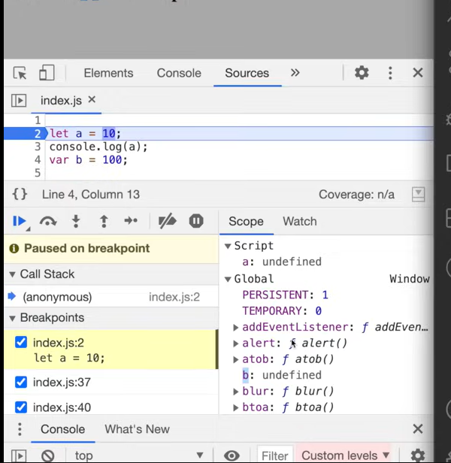
* Let and const have allocated memory but stored in different memory space then global memory and we cannot access it before initialization
* Temp DeadZone is the time between when let is hoisted and initialized.
* 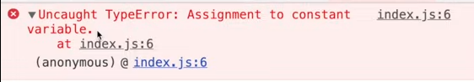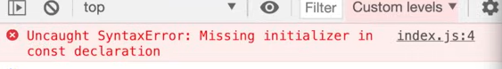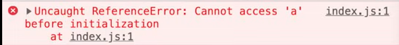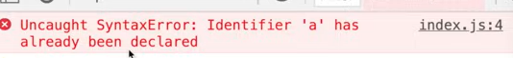 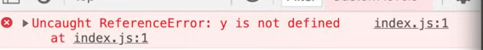
* To prevent form this kind of errors we can declare variables at top and shirnk temp dead zone to 0.

***Block scope & shadowing in JS*** ***–***

* {} this is a block in js , block combines multiple JS statement in a group, we use grouping of statement as to help when js needs only 1 statement 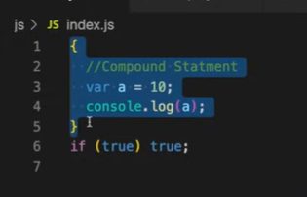 we have grouped the statement inside {} block and now we can use it in if case as there it only expect a statement.
* Let and const are block scoped as they are stored in a separate memory reserved for this , we cannot use it outside this block scope, we can use var outside it as it is stored in global scope
* 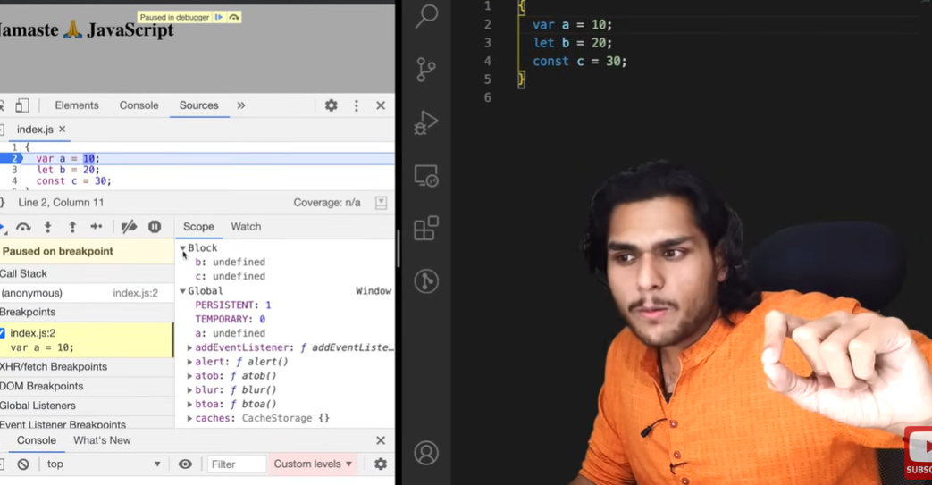
* Shadowing in JS – if we declare variable of same name , one variable shadows other variable (overrides other variable value) this is the case in var not in let, check this in console call stake
* 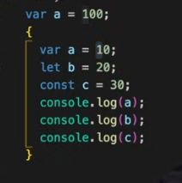 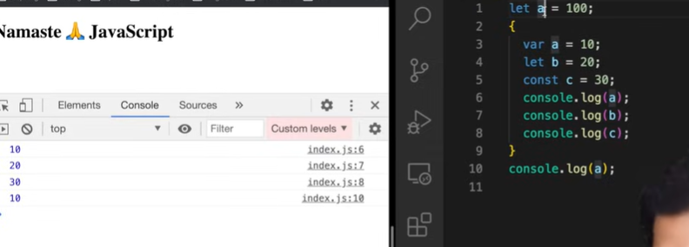
* If we use let inside block scope let Is blocked scope so printing it gives 20 and outside if in different memroy scope so printing it is 100 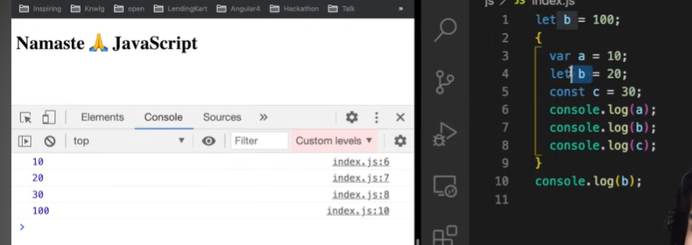
* Illegal shadowing 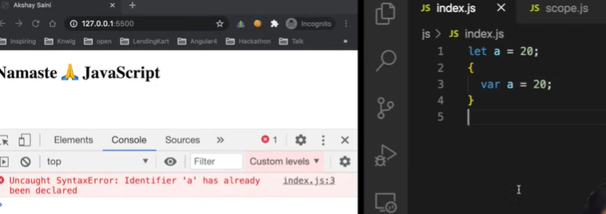 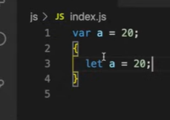 this is valid
* Var is function scoped ()
* 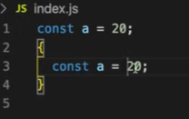 this is also valid
* 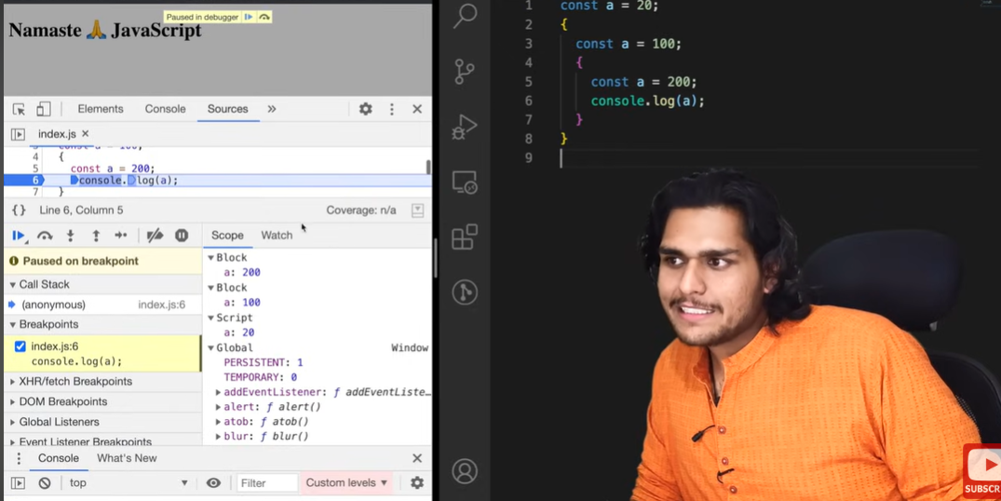this is lexical scope chain one inside other and if one is not present it will take from outside other
* All function scope is same follows in arrow function no difference

***Closures in JS*** ***–***

* Closures in JS – A function bundled together with its lexical environment. Function along with its lexical scope forms a closure
* Inside y it forms a closure with variable which are part of x lexical scope
* Function y bind to variable of x
* 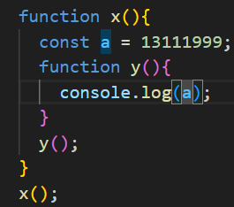 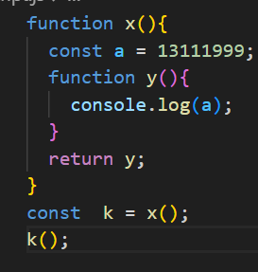
* Actual closure comes in thinking when we return entire function – so here entire function maintain its lexical scope or we can say it remember from where it came actually
* Lexical Scope - **Lexical scope defines the accessibility of variables and functions** depending on their location in the source code. JavaScript uses lexical scoping to resolve the variable names when a function is created inside another function.
* Actually when we return a function , not just function is returned but enitre closure enclosed with function and with its lexical scope is returned
* Function along with its lexical scope bundled together forms a closure.
* Closure : Function bundled with its lexical environment is known as a closure. Whenever function is returned, even if its vanished in execution context but still it remembers the reference it was pointing to. Its not just that function alone it returns but the entire closure and that's where it becomes interesting !!
* 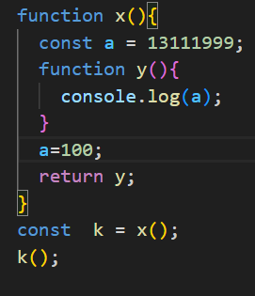here we get a as 100 as y points to reference of a not a particular value
* 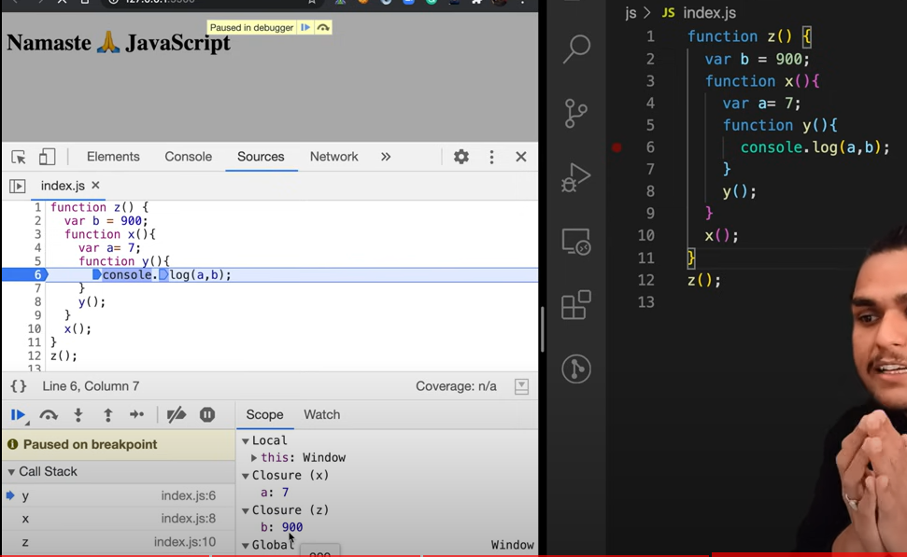y forms a closure with scope of x and z
* 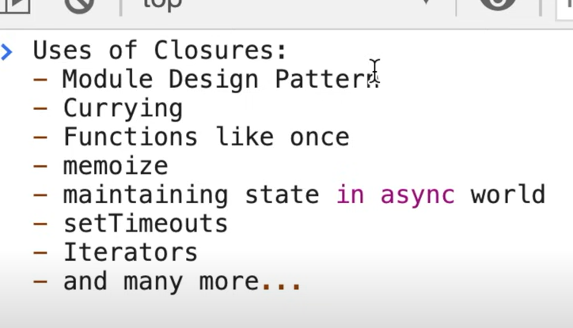

***setTimeout + closures Interview Ques*** ***–***

* Function inside setTimeout remembers reference of i and forms a closure so whereever it go it keep reference of I along with it , settimeout attaches a timer to it and js proceed then when timer expires , js engine takes the function put it in call stack and execute it.
* 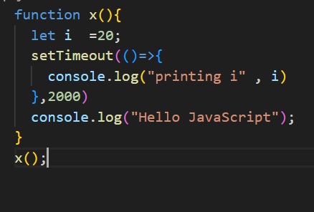 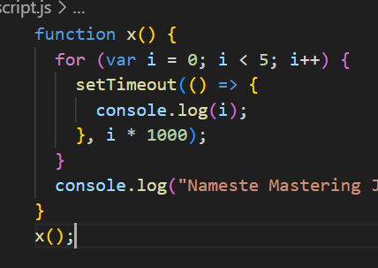 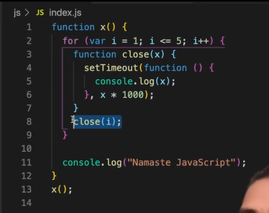
* It prints 5 5 5 5 5 , but why – it is working this way because of clouser , closure is a function along with its lexical enviroment , it can access variables of its lexical scope , so when set timeout stores it somehere and add timer to it , IMP – so that function remember reference to I , not remember value , remember reference i , So when loop runs 1st time it makes a cpy and remember reference to I , same 5 copy is made and it is pointing to same reference of I , because env of all these settiemout is same ,, 2nd thing -- JS waites for nothing it sees settimeout it oddloads it and proceed and entire loop is executes and before any settiemout times finies it becomes too late and for loop continues running var I = 5 now and as settimeout function reference I not value , when times finishes it prints 5 5 5 5 5
* A very quick and easy way to fix it use a let instead of var , As let has a block scope so each and every iteration a new copy of I is there and each time settimeout is run this callback function has new copy of I with it. , function forms a closure with new variable itself.
* So each and every time this setitimout is called it is referring too different memory loaton og I . and it creates a new copy.
* Now how to do it with var , we just have to do new copy of I need to be there , create a function enclose settimeout inside it run it , close(i) , it will pass I and every time we call this close function with I , it creates a new copy of I for itself here , so eeverytme settimeout is called it remember a new copy of x , every time close function is called it has new copy of i.

<https://www.youtube.com/watch?v=t1nFAMws5FI&list=PLlasXeu85E9cQ32gLCvAvr9vNaUccPVNP&index=15> Go through this interview video

***First class func – anonymous function*** ***–***

* What is an anonymous fnct – a function without a name is anonymous function
* What is first class functon –
* What is diff between function statement vs func exp vs func declaration
* 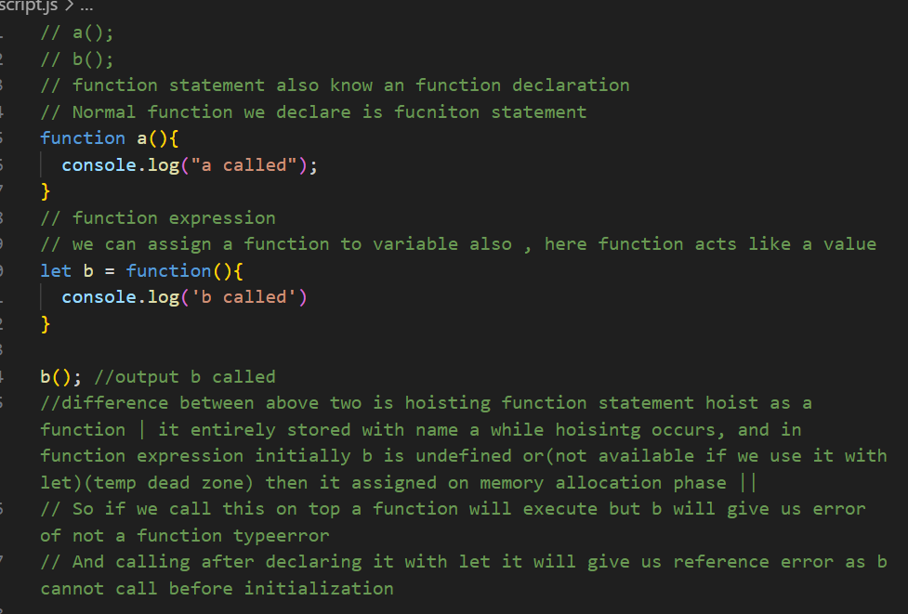 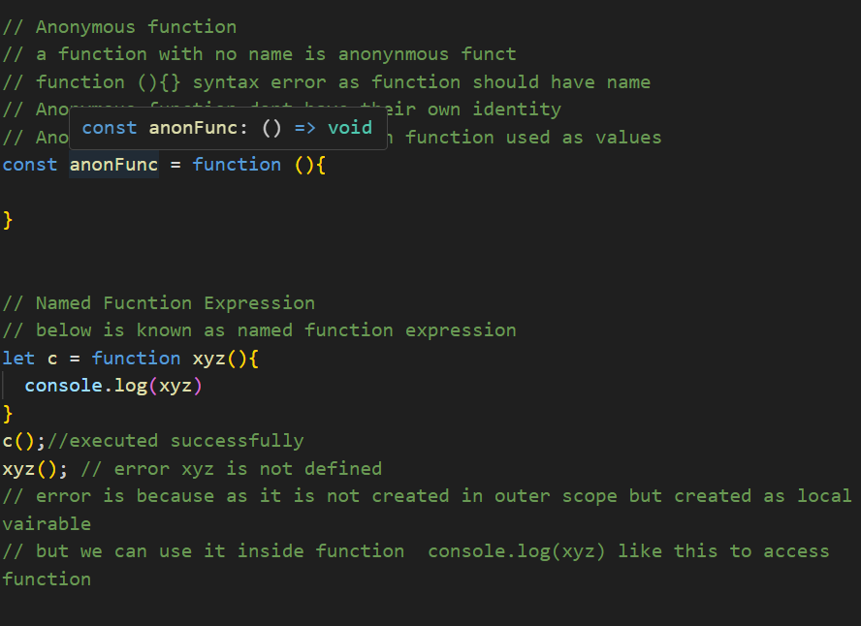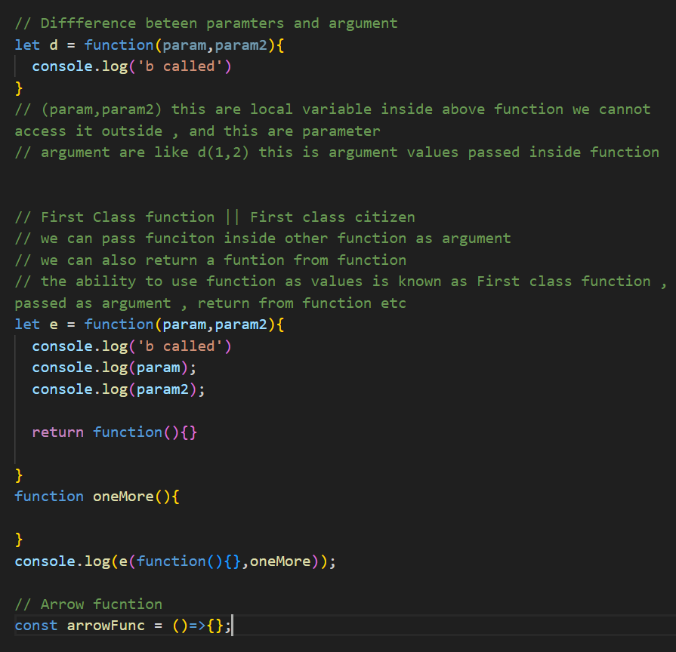

***Callback Functions in JS , Event Listners*** ***–***

* 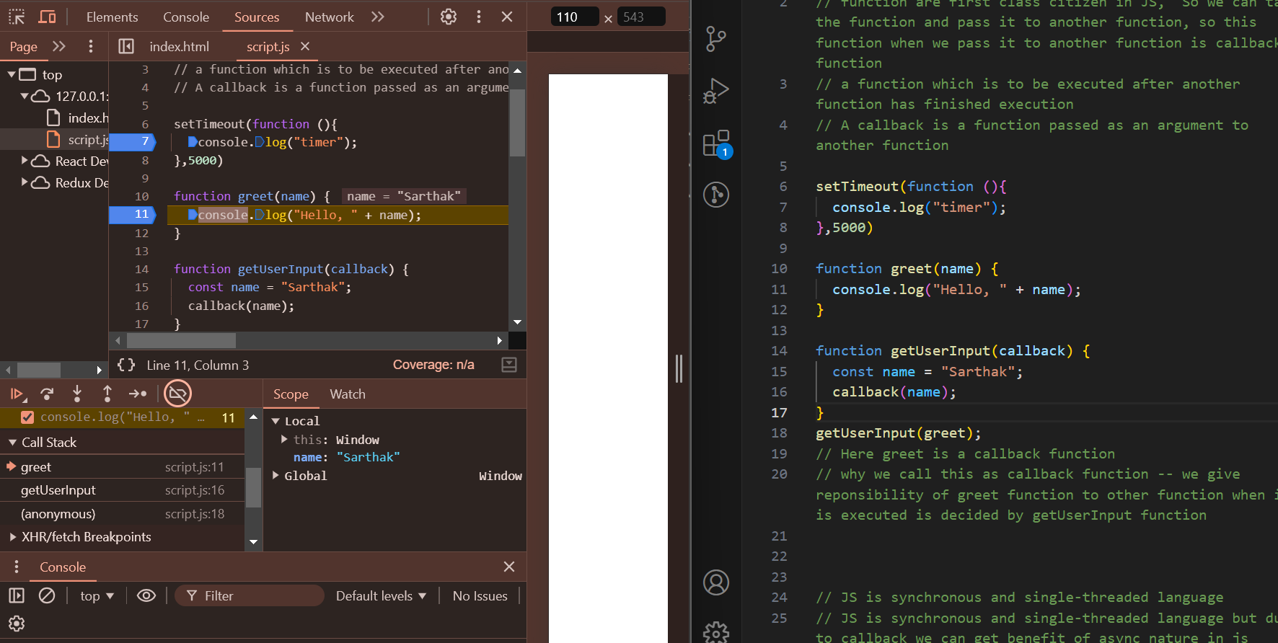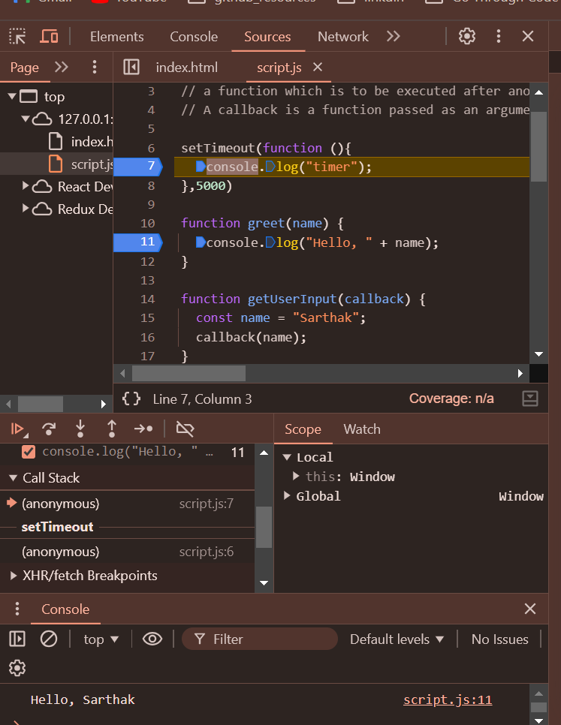
* There is only one thread (main thread) (call stack ) anything execute in code is executed using main thread only so when code runs we can see something in main thread and once it executed it vanishes completely then after 5 sec settimeout again comes in main thread for execution (by this breakpoint we can see there is blank in call stack then settimeout appreas)
* So if any operation blocks the call stack , it means blocking the main thread , so we should never block the main thread, and if any operation takes time we should use async In that case like here we used settimeout
* So If we didn’t have this callback function we cannot pass it to any settimeout or async operation , so we are not able to achieve async nature of programming.
* Watch again from 10:00 min – Very imp
* 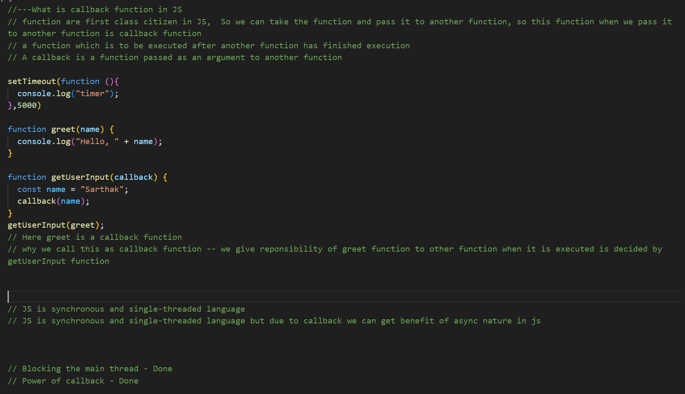 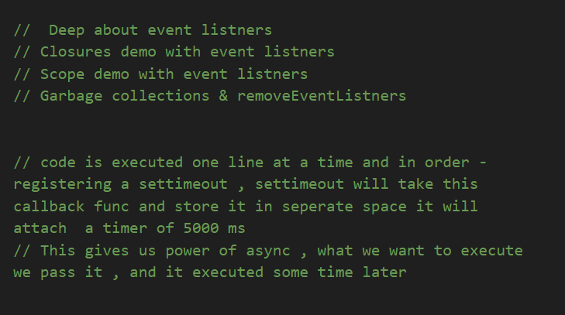

***Asynchronous JavaScript & EVENT LOOP from scratch –***

* Watch this video every time – very important

***JS Engine EXPOSED 🔥 Google's V8 Architecture–***

* JS can run inside anywhere and everywhere , this is all because of JS runtime environment
* In JS runtime – JS engine , API , event loop , callback queue , microtask queue etc
* Now we know why nodejs is called as JS runtime because to execute every piece of code of JS we need JS runtime , and browser have it , now to execute it outside browser we need NodeJS a js runtime
* JS engine is same for all , but API and other superpower can differ
* 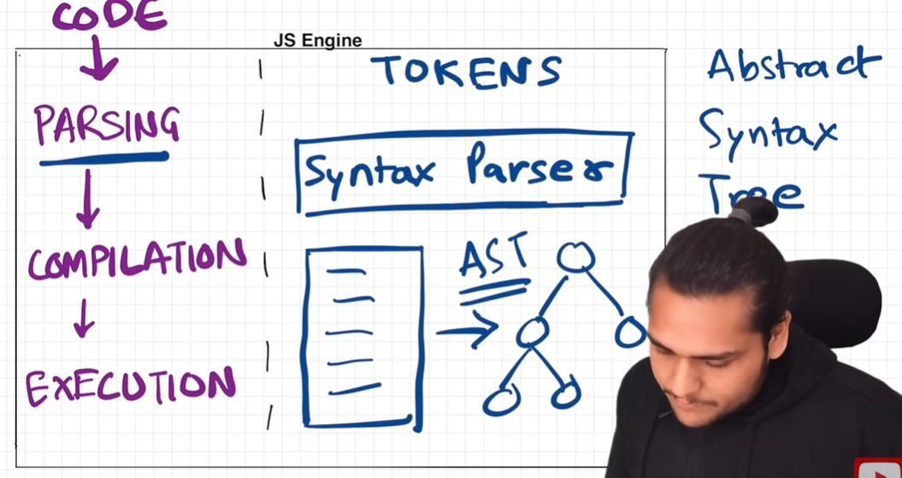 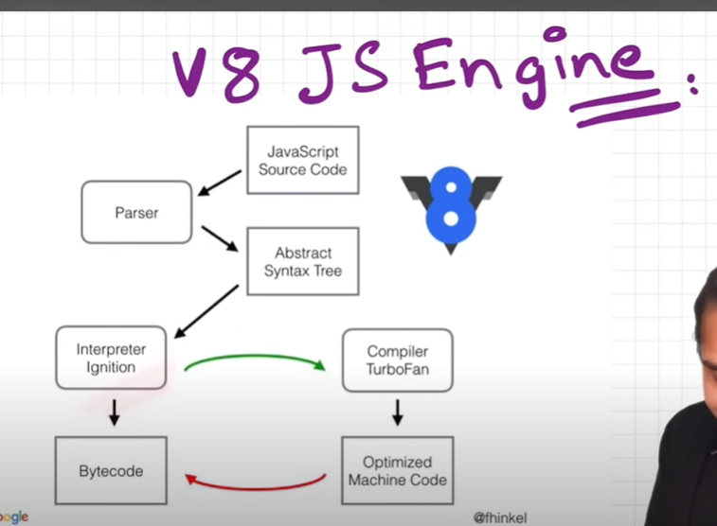
* Watch video again

***TRUST ISSUES with setTimeout() –***

* Settimout with 5 sec delay doesn’t exactly wait for 5 sec , that why it have trust issues
* It can even take 6 sec , 10 sec it all depends on call stacks
* And this also known as concurrency model in JS
* That’s why we say don’t block the main thread (call stack in JS) , because if main thread is blocked it cannot execute mircotask queue callbacks and callback queue callback , everything will be fucked up.
* You can try blocked main tread for 10 sec using date api.
* Watch video again

***Higher-Order Functions ft. Functional Programming–***

* A function which takes another function as argument or returns a function from it is known as HOF
* 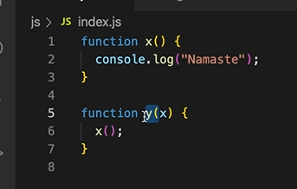 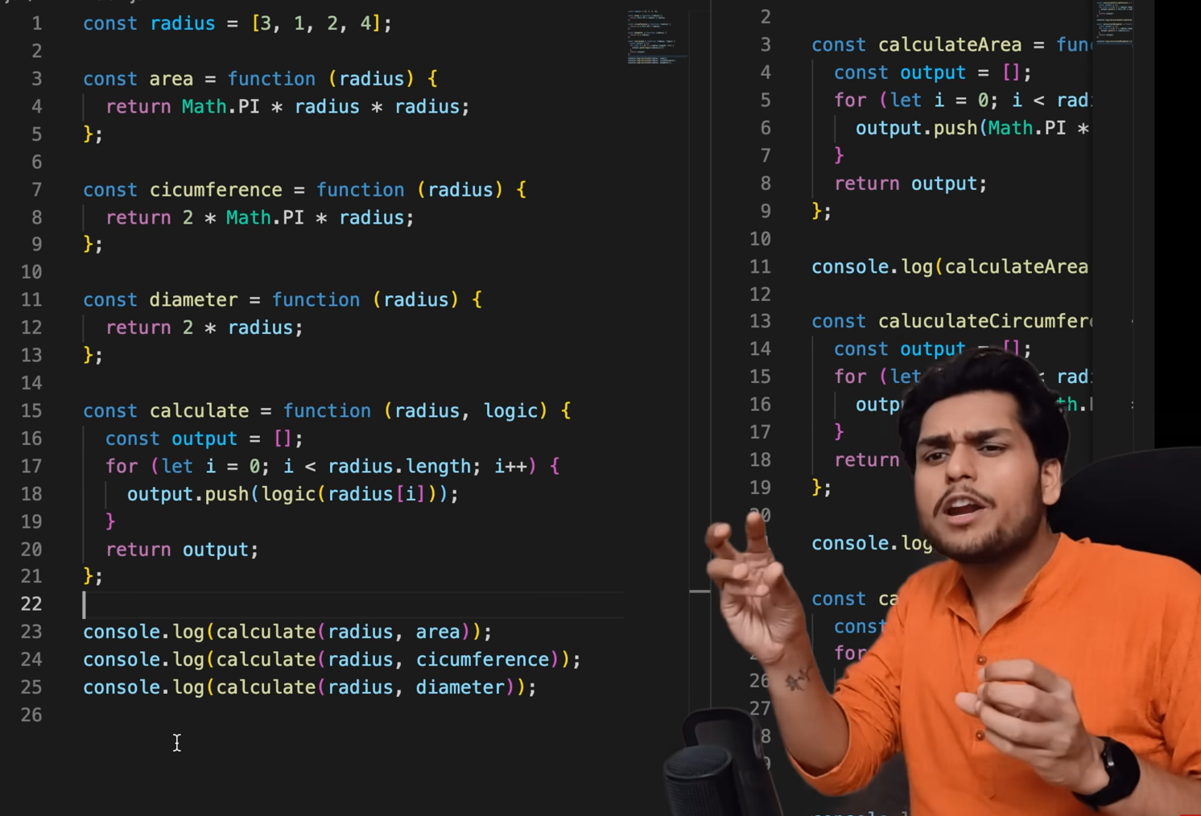
* Here y is HOF and x is callback function.
* Watch video again

***map, filter & reduce –***

* Map() function – Map function is used to transform an array , transform means change each and every value of an array , and get new array out of it. Like below
* 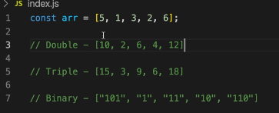 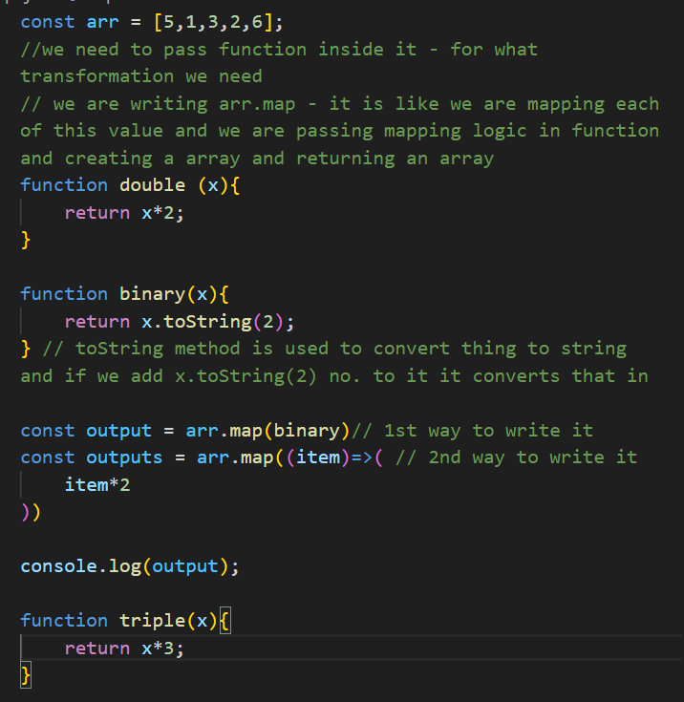
* Filter() function – So filter function is basically used to filter the values inside the array , we can pass any condition (filter condition) based on it. So it returned the filtered array
* 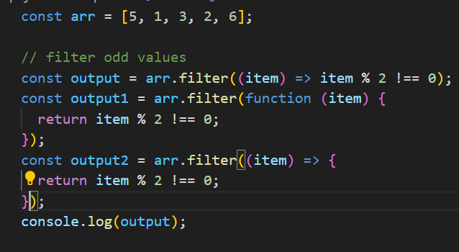
* Reduce() function – Used at a place where you have to take all the elements of an array and come up with a single value out from them. (to find sum, to find max no etc)
* 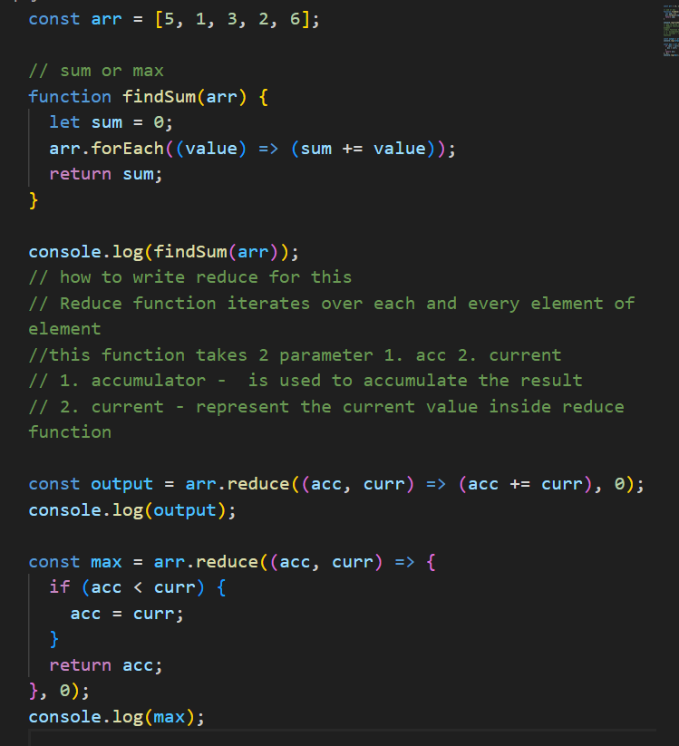 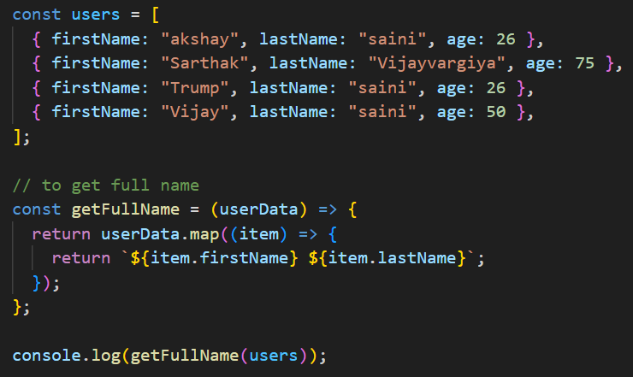 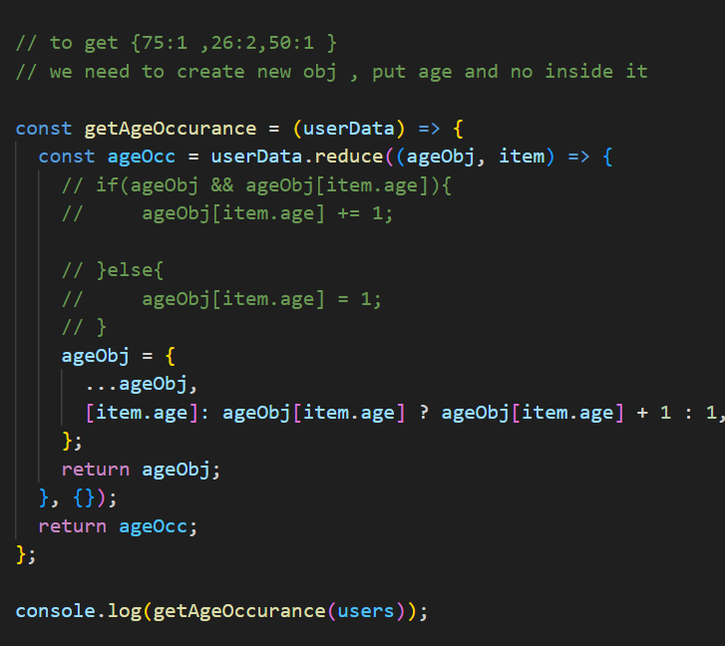 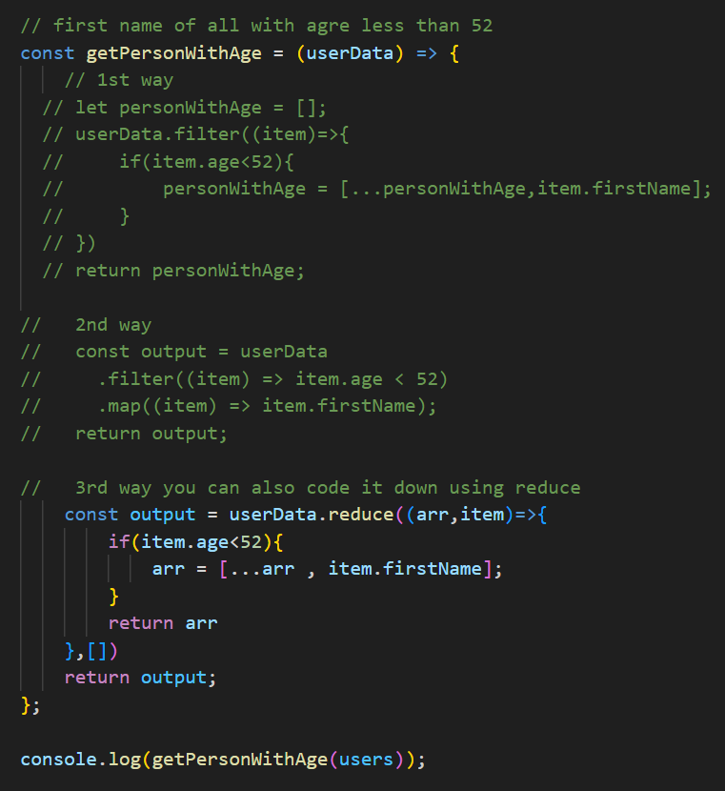

***Core JS Fundamental – Namanste JS***

***call, apply and bind method in JavaScript–***

* 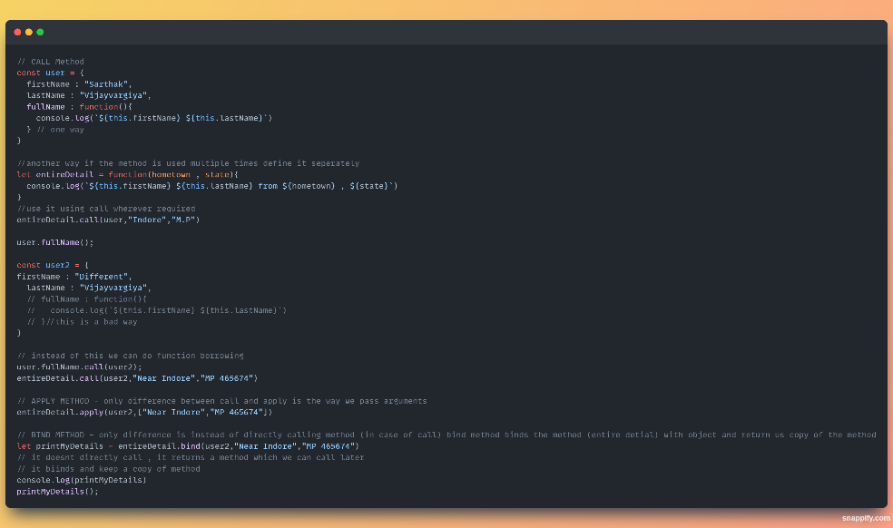

***Polyfill for bind method –***

* Polyfill is kind of browser fallback – suppose your browser doest support bind method , so you have to write your own bind method;
* 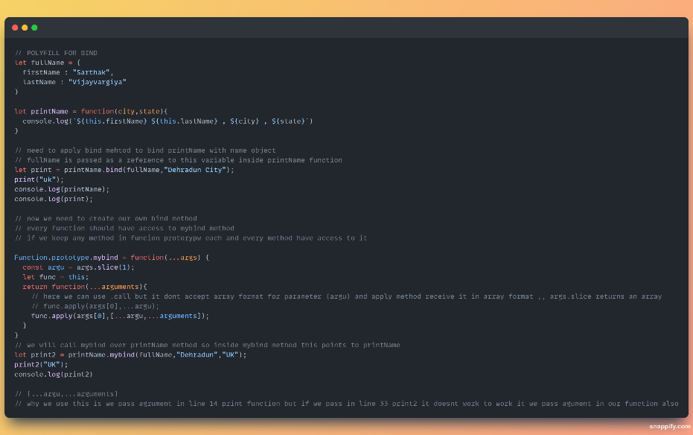

***Currying in JS –***

* A function that expects multiple arguments is broken down into smaller functions, each handling a single argument, and returning a new function until all arguments are provided.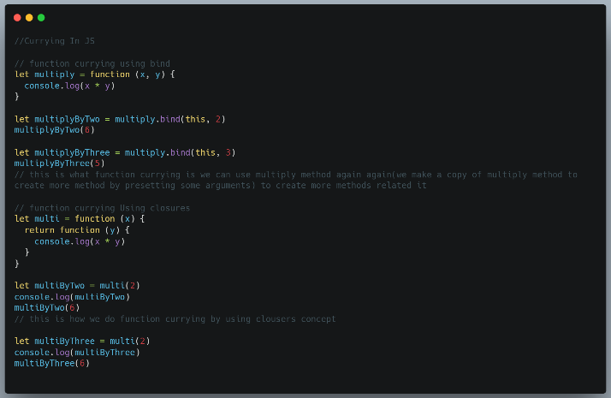

***Sum(1)(2)(3)(4)(5)….() Interview Ques***

* 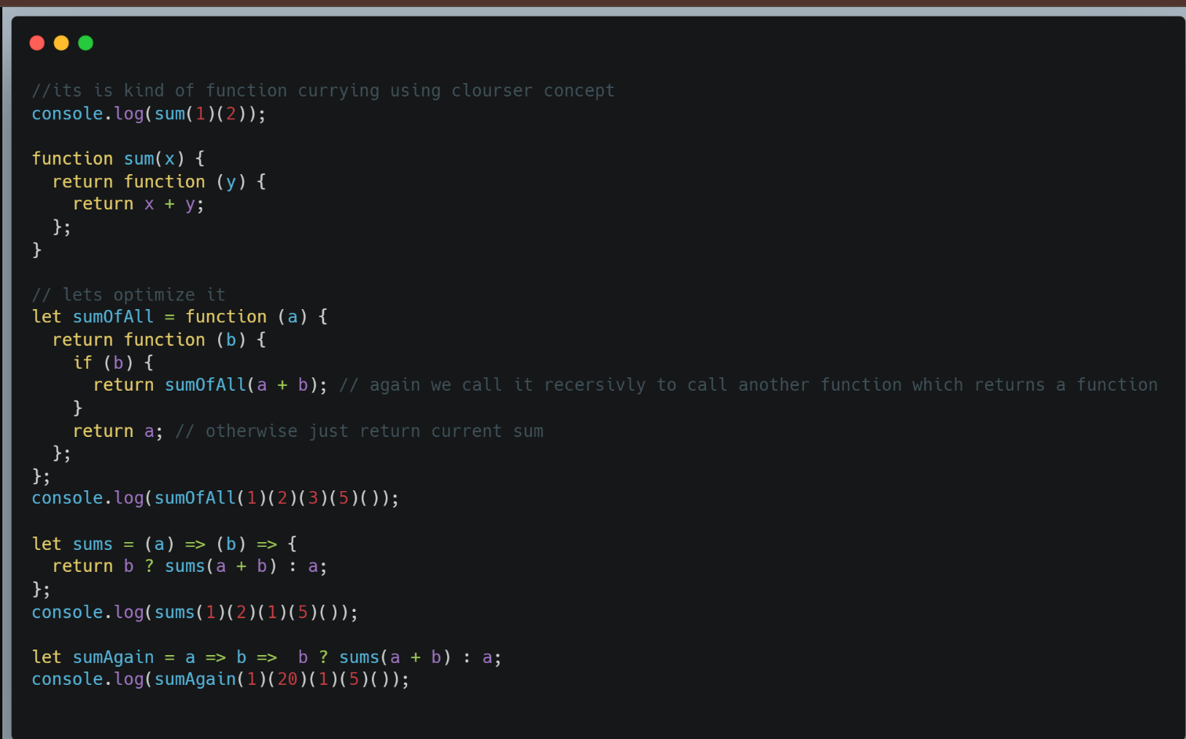

***Debouncing in Javascript –***

* **Definition**: Debouncing delays the execution of a function until after a certain amount of time has passed since the last event. This is typically used when you only want to make a call once the user has **finished** an action.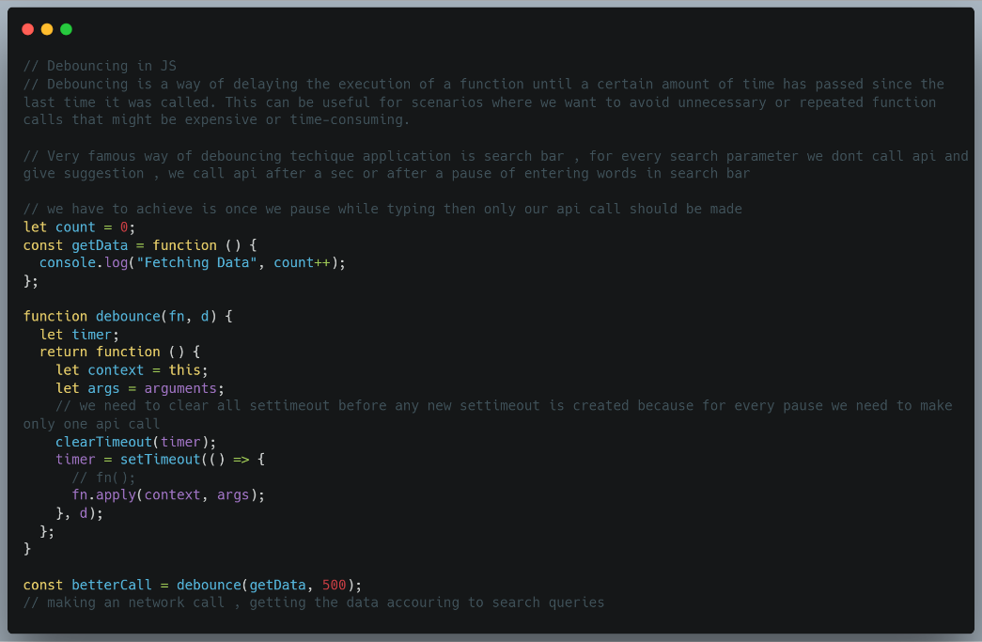

***Throttling in Javascript –***

* 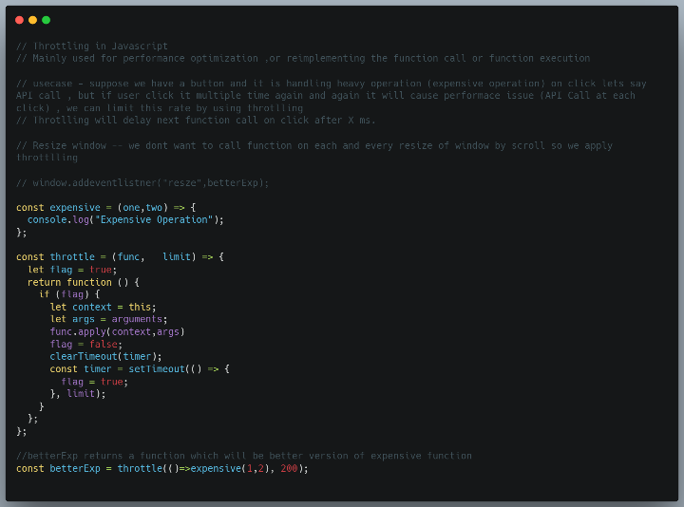
* **Definition**: Throttling ensures that a function (such as an API call) is executed at a regular interval, even if the triggering event (like scrolling) happens continuously.

***Debouncing vs Throttling in Javascript –***

* Both concepts are used for optimizing performance of webapp , it happens by limiting the rate of execution of a particular funtion
* A function call can be anything , Sometimes a function is called lot of times , we attach a function with event handler and it executes again and again unnessserly , we prevent that by these 2 technique
* Example present revisit this.
* 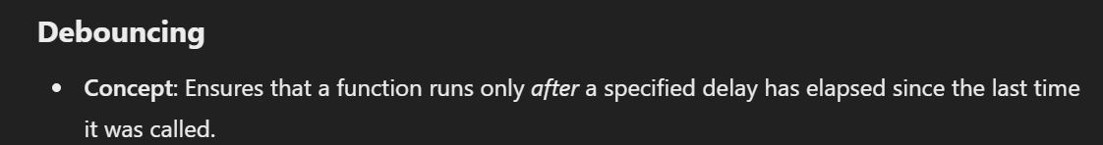
* 
* 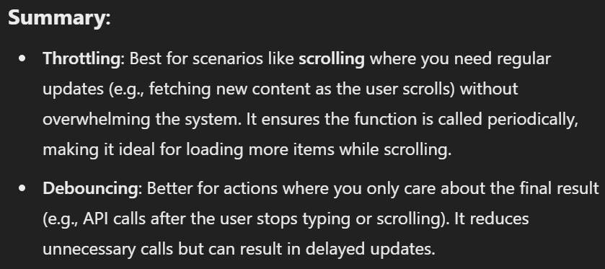

***Event Bubbling, Capturing aka Trickling  –***

* These are two ways of event propogation in dom tree
* If any event trigger happens In child then it will trigger parent as well
* 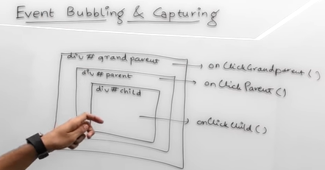
* In Event Bubbling case child() , parent() , grandparent() will be called (also happens in by default). [remember it by bubble always comes out](event is bubbling out from DOM tree).
* In Event Capturing , its top to down , grandparent() , parent() , child(). Also known as event trickling.
* 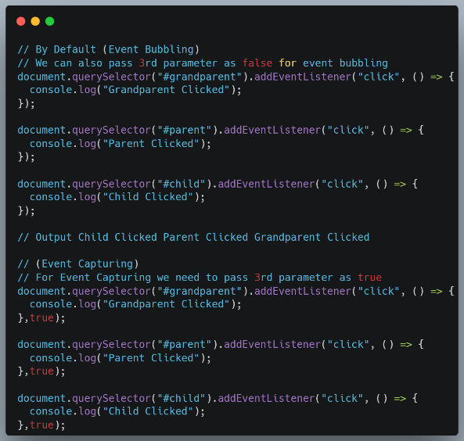 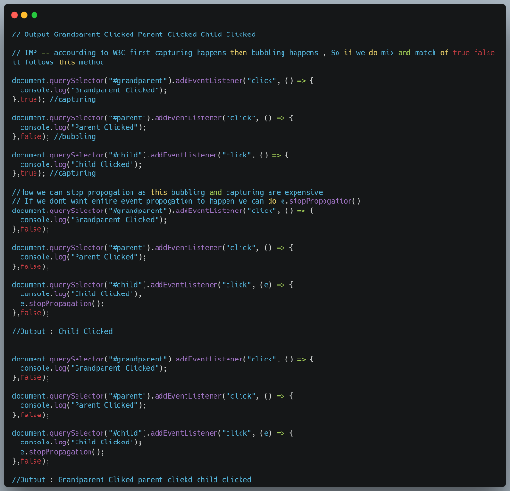

***Event Delegation in JavaScript  –***

* We have lot of events to handle and as our webpage grows , events keep increasing and increasing in a webpage
* So, That’s why we use event delegation it provides us a way to handle our event handlers , So that event does not cause performance issue
* Event Delegation states instead of attaching event handlers to each and every child element, or each html tag , we should directly attach event handler to parent of these element , So when we click on child event because of event bubbling concept parent event is triggered.
* This helped us in optimization , writing less code , DOM manipulation (if new child is added up it can deal with it automaticclay without adding extra event listner)
* Limitation – All events not bubbled up , like blur , focus, resizing of window are some events

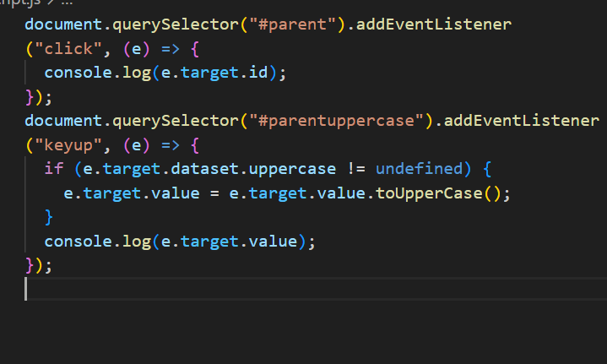 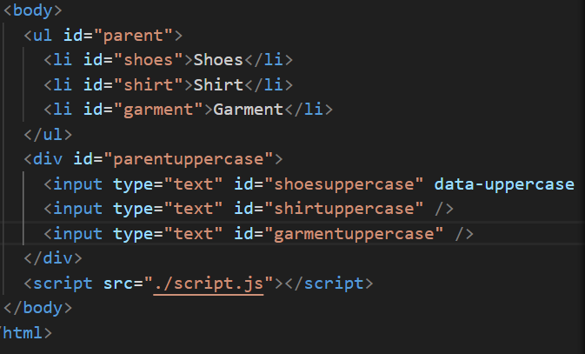

***Prototype and Prototypal Inheritance in Javascript -***

* Inheritance is one object try to use and access properties of other object.
* Prototype – JS object without letting us know attaches some hidden properties and function with our object , these properties and function we can access using object.-- (also applicable for functons , Array , even variable).JS attach object(which have properties) to our object that how we get access to these properties.
* We can access hidden object as arr.__proto__.(propertyname)
* 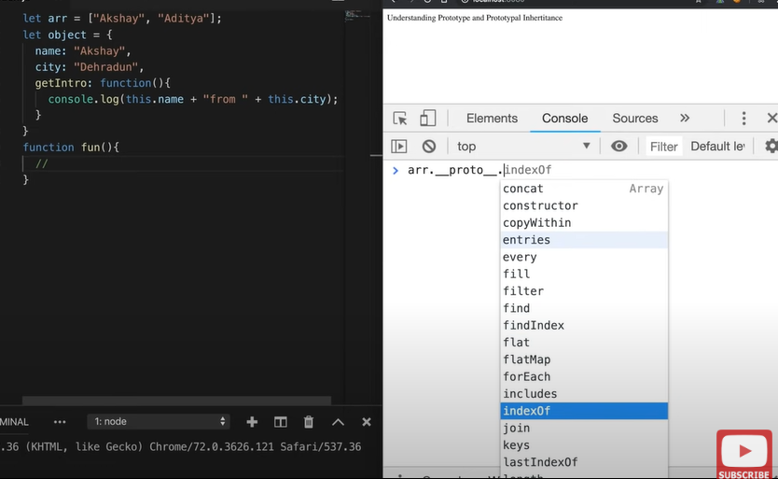 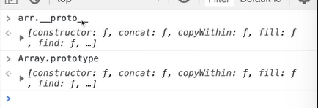
* Even __proto__ is an object and each obj has an prototype so even __proto__ has its own __proto__
* 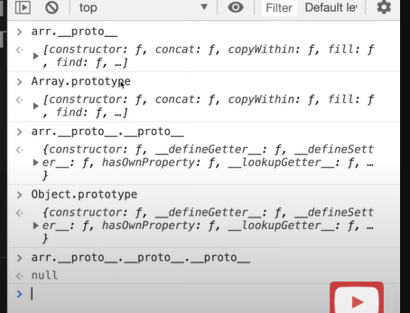 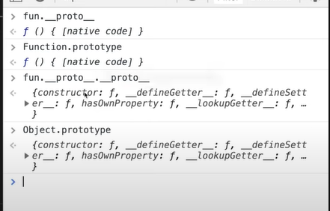 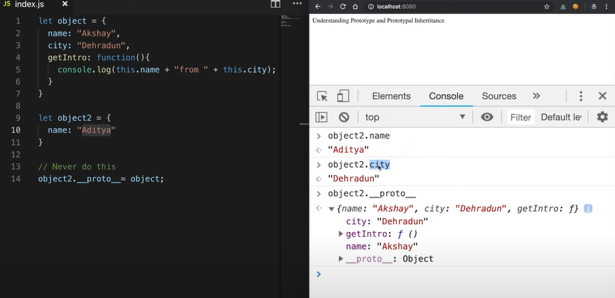
* So if we declare something , down somewhere it it is a object (goes 1 level down down)
* This is whole prototype chain and this is how JS processes this properties.
* Object2 inherites from object that what prototypal inheritqance (object 2 inheriting roperties of object)
* 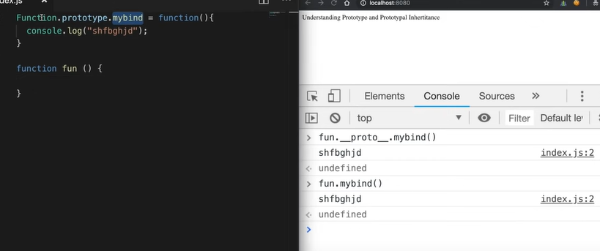Each and every function have access to mybind method

***async vs defer attributes in Javascript -***

* Async and defer are boolean attributes which are used along with script tag to load external script efficiently into out webpage
* When you load a webpage there are two major things happen , HTML parsing , Loading Script (fetching and executing script)
* Async attribute does not qurantee the order of execution of script but defer does
* 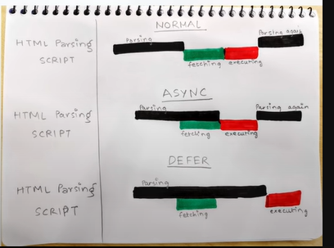

***Local Storage & Session Storage -***

* Web Storage API is used by developers to store some data into web browser and this data is nothing but a key value pair. Two ways to store it Local and Session storage
* Session Storage – Data is persisted for that particular session , As soon as user visit webapp a session is started and data is stored and as soon as user closed the tab or webapp data is lost but it is very useful than cookies (unlike cookies session storage data is not being send to server while making network request and session storage has larger capacty of till 5MB as data)
* Local Storage --- it does not comes with expiry , So can remain there for some period of time even after closing the tab or shutdown , memory capacity is more than 5 MB
* Storage API follows same origin policy – origin comprises of three things – HTTP/HTTPS , Host/Doamian , Port
* Rewatch this video
* Local storge is stored in window object of browser

***Thinking Recursively - IMP***

* When you are doing something in a repetative way , again and again then think it as a recursive approach.
* There are many twisted ways – keys can be very different like instead of just object and strings it can be array , number etc how to deal with them (rewatch) what about properties inside prototype (prototypal inheritance in this case)
* 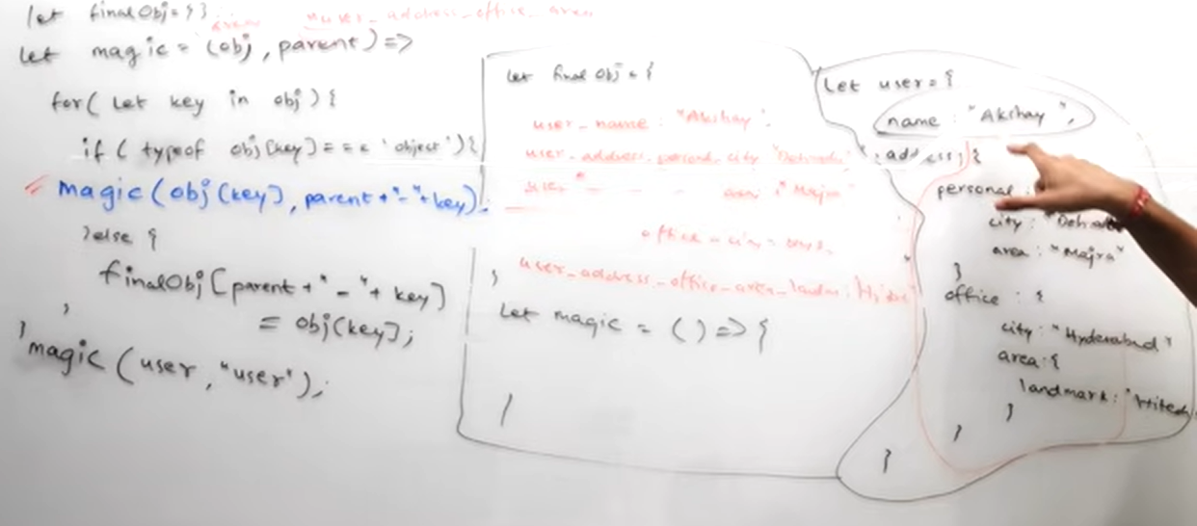

***CORS, Preflight Request, OPTIONS Method | Access Control Allow Origin Error –***

* Cross-Origin Resource Sharing – Cors is a mechanism which uses additional HTTP headers to tell the browser weather a specific webapp can share resource with another webapp and a major imp point is both the web app should have different origin , (if they have same origin they can share resource without any difficulty) , If they don’t have same origin they have to follow CORS mechanism.
* What is different origin , how does it share data , interview ques… (watch again) , read entirely from MDN also
* 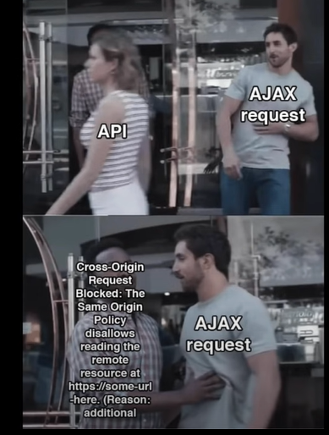

***AJAX & JSON –***

* **AJAX** stands for **Asynchronous JavaScript and XML.** It’s a technique used in web development to send and receive data from a server asynchronously, without needing to reload the entire web page.
* AJAX is a technique that allows web pages to communicate with a server asynchronously. By using AJAX, specific parts of a page can update without reloading the whole page, which is more efficient and provides a smoother user experience
* While AJAX requests can use different formats (like XML, JSON, or even plain text), **JSON** is the most commonly used format because of its lightweight structure and compatibility with JavaScript.
* When we use **fetch with .then().catch()**, **async/await**, or other methods to make HTTP requests in JavaScript, these are modern forms of **AJAX requests**. In the past, AJAX was closely associated with XMLHttpRequest and was often used with XML data, but today **JSON is much more common**, and fetch (or libraries like Axios) has become the standard for handling AJAX requests.
* 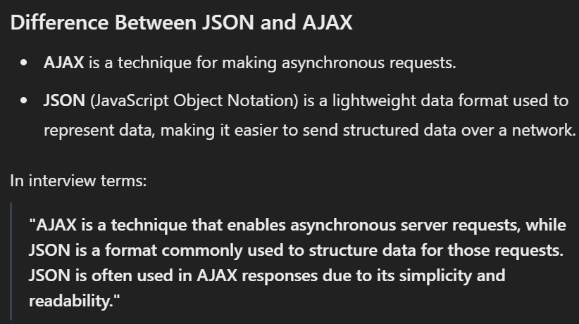

***Zigzag (Spiral) Level Order Traversal 🔥–***

* **JS Interview Medium Level Questions asked in many companies**

***Season 02 - Namaste JavaScript***

***Callback Hell–***

* **JS** does not wait for anyone , so if we want to execute some piece of code after sometime or asyncronously we need callback function (in settimeout) like function(){cosole.log(JS)}
* We pass this callback function to settimeout and now its job of settimeout to execute this callback function after 5 sec.
* 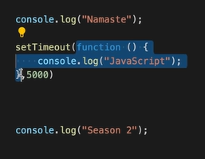 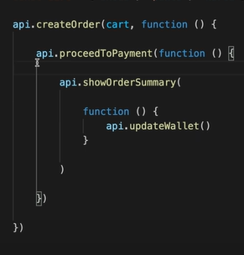 this is a callback hell also known as pyramid of doom 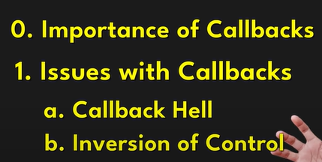
* Inversion of control – means you loose the control of code when we using callback , when we have this callback function and we pass it to some other function we are giving the control of our function (or our piece of code ) to some other code.

***Promises –***

* 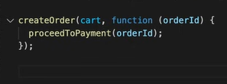 In this we are giving control of our code proceedToPayment to some other createOrder function which is not good (Inversion of control issue). To resolve this we have promises.
* We just call create order API and it will return us a promise.Promise is nothing but empty object with some data value in it.
* Promise object is immutuable , we cant change it , it is great
* Interview - - Promise object is a placeholder for a certain period of time until we receive a value from async operation
* Promise is an object which represent eventual complition of async operation
* This is promise chaining which get us resolved callback hell , promise get us resolved with Inversion of control.
* 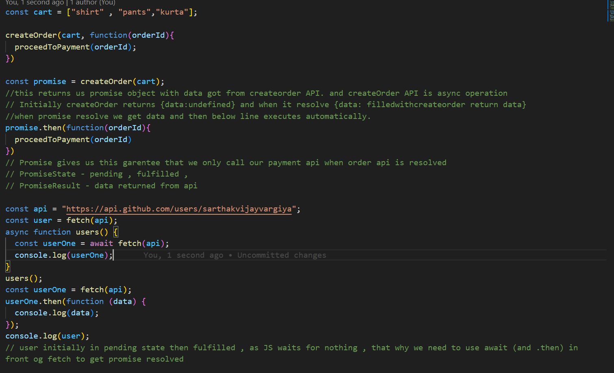 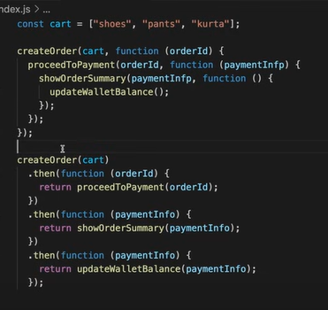

***Creating a Promise, Chaining & Error Handling –***

* Creating our own promise , Also we should gracefully handle all the errors.
* Promise chaining - .then , .then , .then || also remember what we want to pass down the chain we need to return it from above .then that can be data or promise.
* Stick to this vocablarry – So, We are attach a callback using catch or then to a promise object this will handle our error gracefully , also we need to return to pass it to next part of chain. Also catch can be placed anywhere and it will catch error of above that.
* See homework in last 2 min vvideo
* 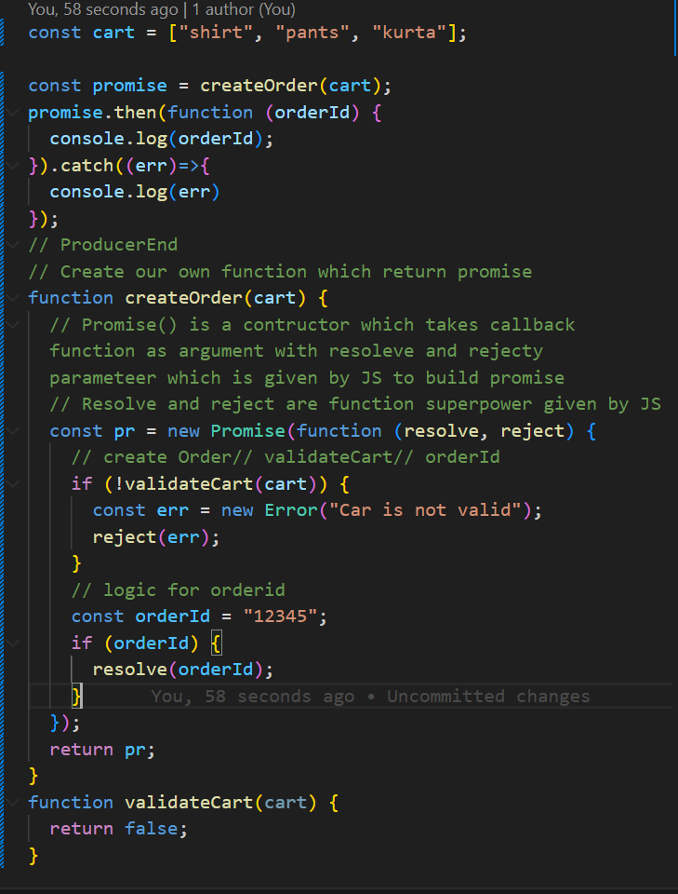 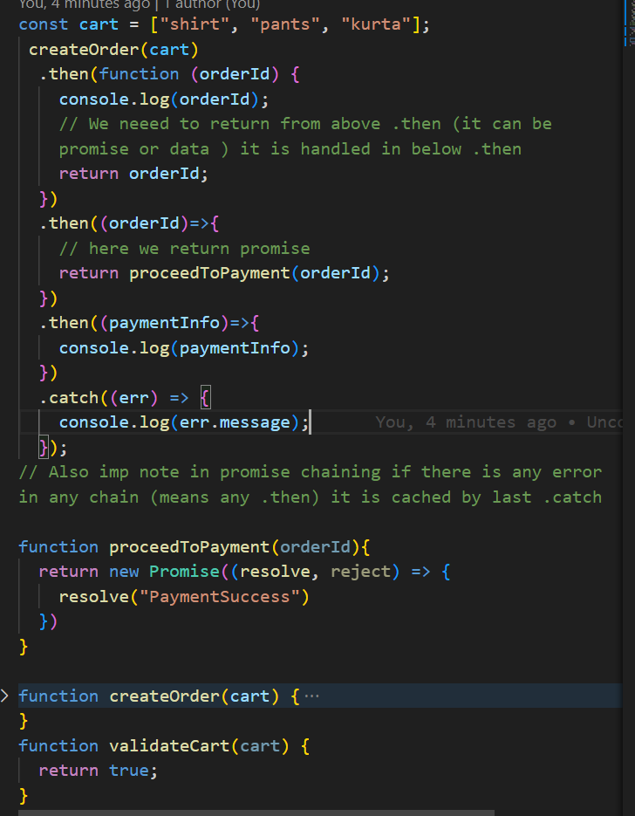

***Promise APIs + Interview Questions -***

* Important in every things like , building react , next applicat*on etc.*
* Promise.all()
  + When we want to make parallel api calls , ex. Like 10 user we want to get information for all users
  + Takes an Iterable (like array) of promises , it will make 3 paraaled api call and get the result , give result as an array of output of promises || but if any of promise fails it will give ouput as error same error which got from failed promise || as soon as we get error , it doesn’t wait for other promises to reject or resolve it just return error.
  + 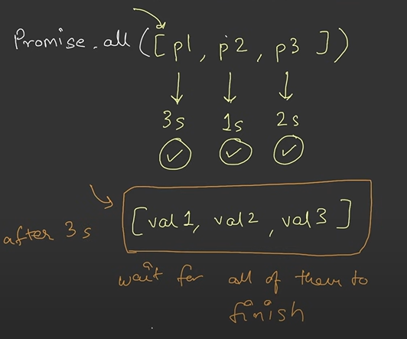 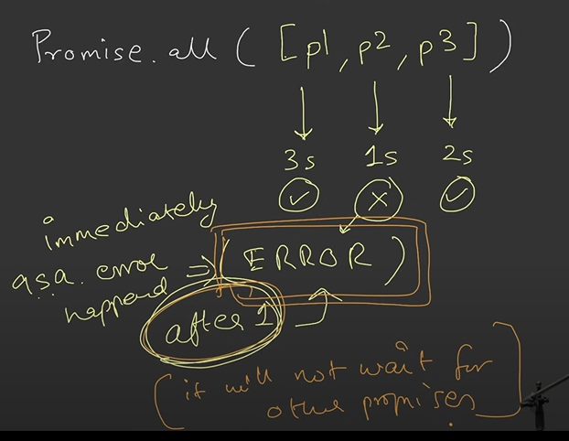
* Promise.allSetteled
  + We get result for all the success promise , doesn’t matter is something we get in error || it will give us a object
  + 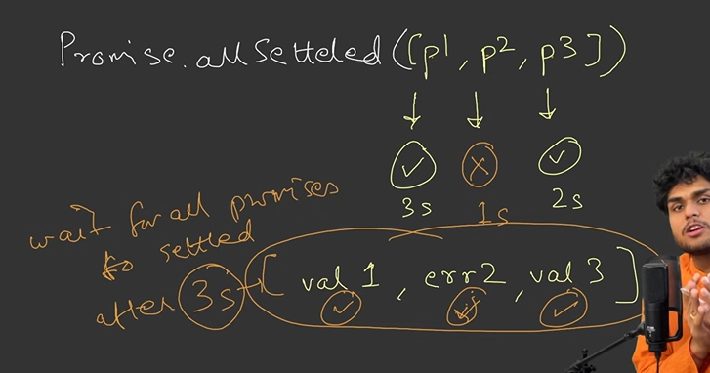
* Promise.race – takes 3 promises , the person finishes the race will be winner , means first promise will resolve we get result of that promise irr respective of success or failuer
  + 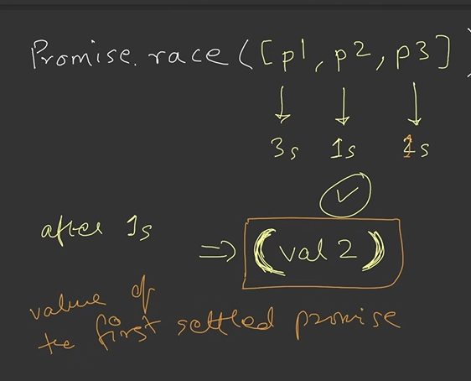 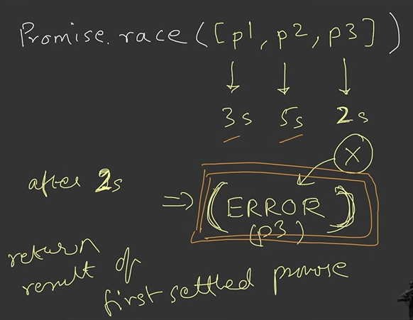
* Promise.any – It is similar to promise.race , but it will wait for first promise to get succesfull
  + 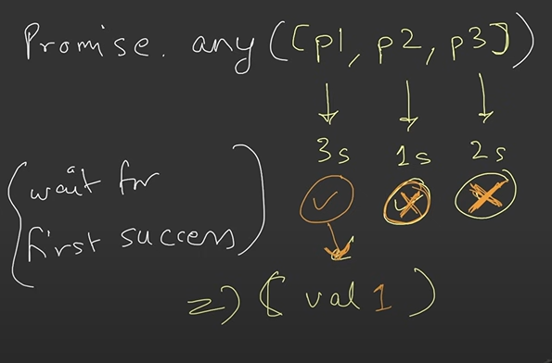 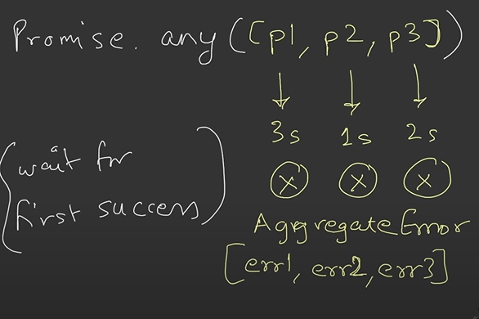
* Imp , remember lingo – settled , fullfilled , rejected, resolve and other as important maje lete h isko leke.
* Examples –
  + 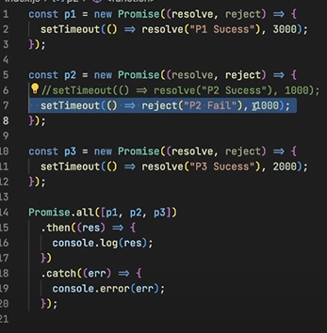 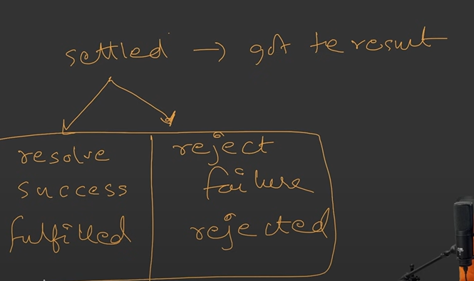 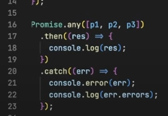

***async await –***

* What is async – async is a JS keyword that is used before function to make it async
* Async and await combo helps us to handle promises
* 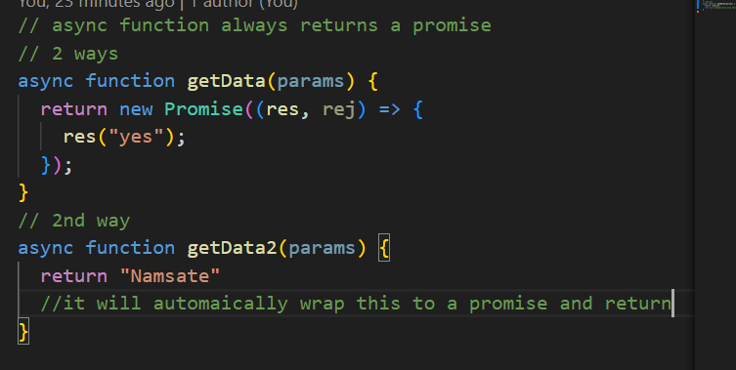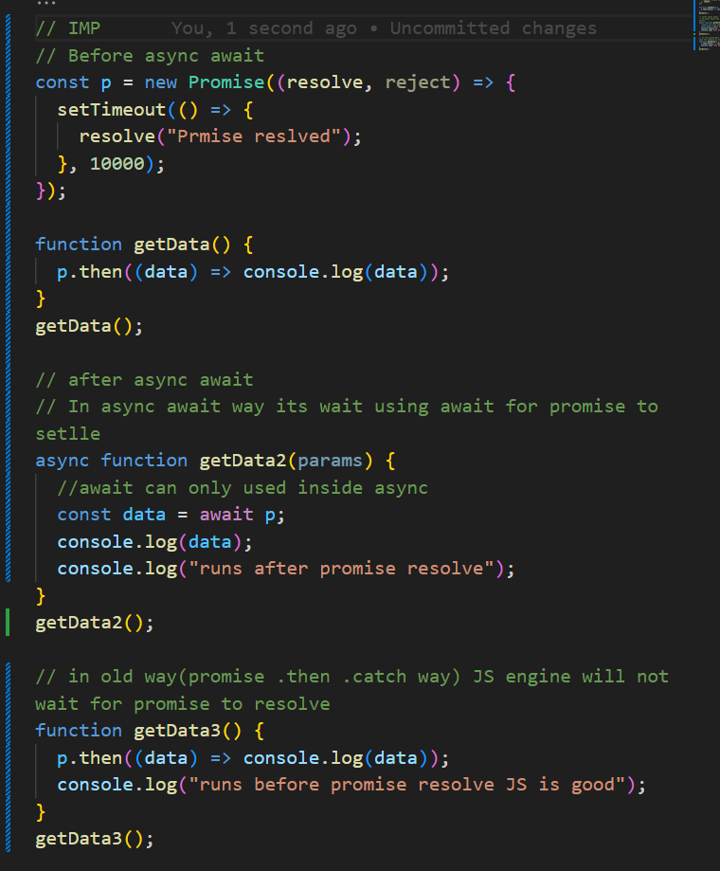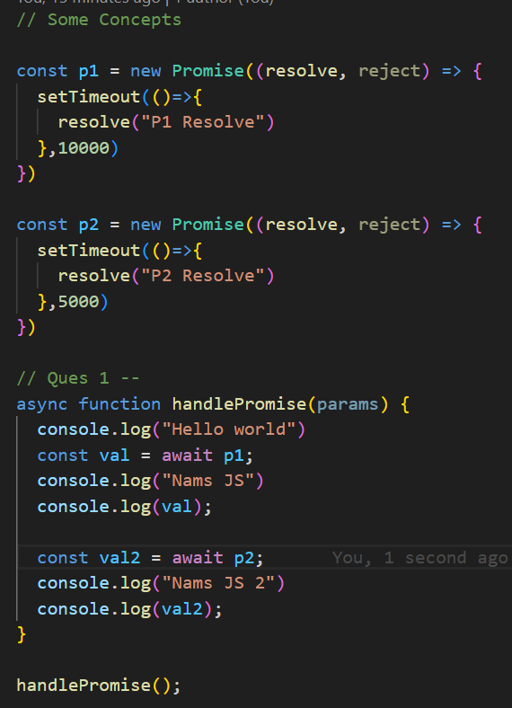
* Watch video again from 30 min
* In Interview – Don’t just randomly start explaining first start what is async and then tell await

***this keyword in JavaScript– -***

* 